Variation in use of East Asian Late Paleolithic weapons: A study of tip cross-sectional area of stemmed points from Korea

Gayoung Park1,✉, Marlize Lombard2, Donghee Chong3, and Ben Marwick1

October 31, 2022

The introduction of blade technology, stemmed points, end scrapers, burins, denticulates, and finer grained materials characterises the transition from the Early to Late Paleolithic in Korea. Stemmed points have been considered a representative tool that led this set of changes. In this research, we examine the possible role that stemmed points played during the technological transition, as well as throughout the Late Paleolithic. Our main questions are: What were stemmed points used for? How diverse were their likely uses? What are the temporal and spatial patterns in stemmed point use? We measured tip cross-sectional area (TCSA) to discriminate different likely use classes of projectile points, for example, as poisoned arrow tips or as stabbing spears. We analyzed TCSA with other variables including raw materials, weight, site and radiocarbon dates. Our results show that the stemmed points were likely used as javelin tips and stabbing spear tips, with smaller numbers as dart tips and un-poisoned arrow tips. TCSA values are controlled mostly by size rather than raw material types. We found different usage of stemmed points at different sites, which could indicate people used stemmed points in different ways depending on the local environment. Some sites show a wide range of TCSA values that represent multi-purpose usage of stemmed points. The temporal pattern of TCSA values is one of little change throughout the Late Paleolithic period. We conclude that stemmed points were multi-functional tools, with many likely designed for javelin and stabbing spear tips.

1 University of Washington  
2 University of Johannesburg  
3 Kyung Hee University

✉ Correspondence: [Gayoung Park <gayoungp@uw.edu>](mailto:gayoungp@uw.edu)

# Introduction

The introduction of new stone artifact technologies marks a major transition in the Korean Paleolithic from the Early to the Late Paleolithic periods. The transition includes the appearance blade technology, stemmed points, end scrapers, burins, denticulates, etc (Bae et al., 2017; Bae, 2017; Lee et al., 2017; Nakazawa and Bae, 2018; Seong and Bae, 2016). Stemmed points are considered the first evidence of a suite of new technologies defining the Late Paleolithic in this region (Seong, 2008; Seong and Bae, 2016). This is related to the fact that stemmed points originate from Korea and spread throughout Northeast Asia, and they have a close association with mobility, site formation, and occupation diversity (Chong, 2021; O’Driscoll and Thompson, 2018; Park and Marwick, 2022). Despite the importance of stemmed points, only a few studies to date have examined their likely uses. Previous work has mostly debated their origin, the chronology of the Korean Late Paleolithic, and their relationship with Japan (Chang, 2013; Chong, 2021; Lee and Sano, 2019; Park, 2013).(Chang, 2013; Chong, 2021; Lee and Sano, 2019; Park, 2013).

To understand the likely roles that stemmed points played in the technological transition, this study examines the possible uses of stemmed points. We use the tip cross-sectional area (TCSA) metric to infer likely artifact use, and compare the results to other archaeological and ethnographic assemblages based on the idea that different shapes correspond to different weapon types (Lombard, 2021). We then explore the relationship between likely use and raw materials, artifact size and discard location, and how these change over time. Our main questions are: What were the best-fit ballistic probabilities for the stemmed points if they were hafted as weapon tips? How diverse were their likely uses? What are the temporal and spatial patterns in stemmed point uses? As part of our discussion, we examine possible connections between the roles of stemmed points and population dynamics or environmental change during the Late Paleolithic period. In order to understand how a certain weapon-tip type was chosen, we apply an evolutionary perspective with the assumption that people chose their weapon tip types depending on their hunting strategies and socio-environmental circumstances.

## Stemmed Points in Korea and East Asia

Stemmed points (Sumbejjirugae in Korean) are projectile points made on an elongated blade-like flake or blade with two parallel facets and a single or two arises that converge to form an inverted “Y” (Pratt et al., 2020) (Figure 1). Slight retouch is typically located on the proximal end to shape an acute tip and on the distal end to make a stem, which connects to a wooden shaft. Elsewhere in the world these types of artifacts are often called ‘tanged points’, but we prefer ‘stemmed point’ here to distinguish from Bronze Age stone projectile points that have long been called ‘tanged points’ in Korea (Park and Marwick, 2022). After the first discovery at the Suyanggae site, more than 450 stemmed points have been found in over 30 sites throughout South Korea (Chong, 2021). Understanding the emergence of stemmed points is relevant to general questions about the origins of projectile technology, the emergence of the Late Palaeolithic, and relationships to adjacent regions in East Asia, such as Japan.

Stemmed points are the first composite tools in the Korean Paleolithic that required two different parts, consisting of a stone point and shaft, presumably made out of wood (Seong, 2008). Using blades as the blank for the point enables mass production for this composite tool and its shape can become more standardized (Lee, 2015; Park and Marwick, 2022). Therefore, O’Driscoll and Thompson (2018) claims that understanding the emergence of projectile technology gives insights to greater cultural, evolutionary, and behavioral cognitive flexibility.

Since stemmed points represent the beginning of the Korean Late Paleolithic, investigating their origins is important for understanding the technological transition from the Early Palaeolithic, modern human dispersals into the region, and claims for the existence of the ‘Middle’ Paleolithic in Korea (Bae, 2017; Bae, 2010; Norton and Jin, 2009; Seong and Bae, 2016). There has been a noteworthy debate about explaining the origin(s) of stemmed points which can be summarized into two competing models: a ‘heterogenic’ migration (Bae, 2010), and an *in situ* evolution model (Seong, 2009). The migration model claims that the new blade industry including stemmed points, and the earlier coarse flake tradition including large cores, polyhedrons, choppers, and even handaxes, came from different origins (e.g. 1: North route: Siberia, Mongolia, or other regions of northeast China, and 2: South route: southern China) as the result of a continuing influx of modern human migration from two routes. The *in situ* model argues that stemmed points and other Late Paleolithic technologies, including blade industries, autonomously emerged in the south of the Korean peninsula, with no apparent external influence. The difference between the two models comes from how to understand a few early sites that contain stemmed points but no blades and blade cores. The *in situ* model claims that stemmed points appeared before blades by acknowledging those early sites, including Bonggok, Songamri, Yonghodong, and Hwadaeri, while the migration model supports the traditional definition of the Late or Upper Palaeolithic in Europe and Africa that started with emergence and establishment of blade technology (Seong and Bae, 2016).

Stemmed points are important proxies to understand human behaviors during the Late Palaeolithic. Park and Marwick (2022) examined mobility and site occupation patterns by applying concepts of human behavioral ecology to lithic assemblages and found that forager groups using stemmed points may have been associated with the occupation of marginal or extreme environments, compared to groups with no stemmed points. Also, stemmed points were more frequently associated with expedient technologies, indicating residential and less mobile behaviors. Chong (2021) claims that the morphological variation of the stemmed points along with tool types in lithic assemblages, assemblage size, use of raw materials, and types of blanks could represent specific characteristics of occupation such as a “limited activity station” and a “residential base camp.” For example, stemmed points with high morphological variations in a tool size, shape of edge, degrees of damage, and types of edge retouching from Yongsandong site may indicate that the site was used for specific or limited activities such as hunting (Chong, 2021; Kim, 2004; Seong, 2015).

Stemmed points in both Korea and Japan have been studied since the late 1980s as a part of evidence for long-distance/maritime cultural interchanges or social networks (Lee, 2015). Stemmed points from the Bonggok site in Korea are currently accepted as the oldest ones among Northeast Asia, dated to ca. 41.5 ka, and made on elongated flakes (Bae et al., 2017; Seong, 2015, 2009). After their first appearance in Korea, stemmed points (Hakuhensenntouki in Japanese) appear in Kyushu, Japan during late MIS 3. In addition to the stemmed points, there are similar artifacts found in both regions such as microblade cores, Moppule-seokgi (Kakusuijyosekki in Japanese), backed knife, bilateral points, bifacial points, and transport of obsidian (Chang, 2013; Kim and Chang, 2021; Lee, 2015, 2012). Stemmed points are thus important for understanding the connections and technological transitions between islands in Japan (Chang, 2013).

|  |
| --- |
| Figure 1: Stemmed points from Yongsandong site. 1-6: plain stemmed points, 7-8: one side denticulate stemmed points. |

## Uses of stemmed points

Though stemmed points are generally assumed to have been hunting armatures (Chang, 2013; Lee and Sano, 2019; Lee and Jang, 2011a; Lee and Kong, 2002a; Seong, 2008), it is difficult to understand the likely uses of the tools without knowing their complete shape when attached to other components. Preserved wooden components of projectile tools are too few and rare to generalize the overall scale and variability of the tools used in prehistory (Shea, 2006). Lee and Kong (2002b) claimed stemmed points were ‘stemmed tools’ because of their diverse shapes, which could represent different functions, as well as the uncertainty of complete tool shape. Other researchers agree that some stemmed points that are not symmetrical and have retouch on one side of the artifacts or have denticulate blades on one side should not be called stemmed points but instead stemmed knives, stemmed side-scrapers, stemmed end-scrapers, or stemmed burins (Kim, n.d.; Lee and Jang, 2011b; Seong, 2008) Figure 1: 7-8.

Most stemmed points are symmetrical from the tip to the tang, having the central axis function as a line of symmetry (Lee and Jang, 2011b). Studies of stemmed point manufacturing processes and the patterns of broken pieces show that stemmed points may have been used mainly as spear tips (Chang, 2002; Lee, 1985). There are a high proportion of broken tips and stems and the reused tools were repaired based on keeping the symmetry (Kim, n.d.; Park, 2013). In addition to the morphological aspect of stemmed points, investigation of the whole site and tool composition of an assemblage shows that stemmed points or stemmed tools are strongly associated with hunting activities including peeling the animal skin after slaughtering or separating the bones from the flesh (Chong, 2021; Seong, 2008).

A recent study conducted use-wear analysis on 95 stemmed points from the Jingeuneul site, along with examining fracture patterns, TCSA, tip cross-sectional perimeter (TCSP), and neck width to understand the use of the tools (Lee and Sano, 2019). Their results show that a considerable number of the stemmed points show diagnostic impact fractures (DIFs) on the surface, which likely occurred due to longitudinal forces from the shaft when a stone tip hits a target. In other words, their research indicates that stemmed points may have been used as spear-throwers or bows (Sano and Oba, 2015).

## Tip Cross-Sectional Area

Tip cross-sectional area (TCSA) of stone artefacts has been used as a ballistically relevant standard to probabalistically discriminate different between functional classes of projectile armatures such as spearthrower (a.k.a. atlatl) dart tips, un-poisoned arrow tips and large stabbing/thrusting spears (Lombard, 2021, 2020; Lombard and Shea, 2021; O’Driscoll and Thompson, 2018; Sisk and Shea, 2011). It is important to note that the TCSA metric alone cannot unambiguously determine artifact function, it only suggests a best-fit ballistic probability for the points if they were hafted as weapon tips. The TCSA metric indicates the part of the tool that cuts the target’s hide and relates to weapon flight and penetration dynamics (Hughes, 1998; Lombard, 2021; Sitton et al., 2020). This method was first proposed by Hughes (1998) and and tested by Shea (2006) by comparing archaeological examples to ethnographically collected samples of known use. Shea (2009) also applied this approach to compare projectile points from Africa, the Levant, and Europe, and claimed that projectile weapons first appeared in Africa. A key advantage of the TCSA metric is its convenience: regardless of point type, only maximum width and thickness measurements are needed for calculating the TCSA value (0.5 x maximum width x maximum thickness) (Lombard, 2020; Sisk and Shea, 2011). Later, Sisk and Shea (2011) proposed an alternate measure, tip cross-sectional perimeter (TCSP), for more accurate measure for the force needed to penetrate a target to a lethal depth while TCSA metric is more associated with cutting aspect. However, TCSP has a few disadvantages that limit its applicability to our case study of Korean stemmed points. The force and penetration depth are not only affected by the stone tip, but also by the mass of the shaft, which cannot be known for most archaeological stone-tipped weapons (Lombard, 2020). (**sisk2011?**) also mentioned that TCSP cannot be applied to backed pieces that are hafted as projectile armatures.

Lee and Sano (2019) first applied TCSA to stemmed points from Korea along with use-wear analysis. In that study, stemmed points were analysed from Jingeuneul, located in southwest of Korea, which has the largest number of stemmed points (n = 99) ever found in a single site. For TCSA, they were only able to use ten stemmed points because they needed to select the stemmed points that retained the widest and thickest part of the specimens for TCSA metric and also displayed diagnostic impact fractures for the use-wear analysis. The purpose of using TCSA in their research was to compare the values to North American dart tips and arrowheads. Their results show that the TCSA range of Jingeuneul stemmed points is relatively wide, overlapping with both North American dart tips and arrowheads. Inspired by Lee and Sano (2019) and TCSA research from lithic assemblages in other parts of the world, we aimed to investigate TCSA values for a large number of stemmed points from all over South Korea to better understand their likely uses during the Late Paleolithic.

# Methods

## Archaeological sites

|  |
| --- |
| Figure 2: Korean Paleolithic sites mentioned in this study |

Since the first evidence of the Korean Late Paleolithic was discovered at Seokjangri site, including blades and a stemmed base, around 300 stemmed points have been found in Korea (Lee and Sano, 2019; Sohn, 1967). Most sites contain only a few stemmed points and only a few sites have many more, such as Jingeuneul, Suyanggae (n = 55), and Yongsandong (n = 38) (Kim, 2017). Among these stemmed points, we selected those that retained their widest and thickest parts. Our dataset contains stemmed points that were found during field surveys as well as those were from sites that were never dated but were associtaed with other Late Palaeoltihic artifacts. Applying these sampling criteria resulted in a sample of 173 stemmed points from 36 assemblages unearthed from 29 sites spanning the period 44-10 ka (Figure 2). The dimensions of the 173 stemmed points were obtained from published excavation reports and by direct measurements during our visits to the collections of local museums and archaeological institutions in Korea.

We distinguished between multiple assemblages at a single site where numerous excavations have been conducted in different locations at the site, and by different institutions under the same site name. For example, Suyanggae site, a registered Korean National Heritage site, has been excavated more than ten times since 1980 by the local university museum and later by archaeological research institutions. There are six different excavation locations that range from a few meters apart to a few kilometers. Similarly, we identified multiple assemblages in a single excavation or even a trench where archaeological deposits were separated by culturally sterile deposits, or where distinct artifact-bearing stratigraphic units could be identified by major differences in the texture, color, and composition of the sedimentary deposits. As a result, in this research we used four assemblages from the Suyanggae site. We separated one assemblage among the four by using a different site name, Hajinri, following the convention established the excavators of that location. Because Hajinri was from the sixth excavation area, which is 3.5 kilometers apart from the other spots and dated to much earlier (around 42-30 ka) than the other assemblages (around 31-15 ka). According to the excavation reports for Hajinri, stemmed points first appeared in Hajinri around 42 ka with the earliest blade and blade cores (Lee et al., 2018). We consider this assemblage as an unusual outlier because the stemmed points and blades from Hajinri are so early and also so highly standardized and refined, which are only found at other sites much later in time. We have more confidence in finds from Bonggok, which has the second-earliest dates (41.5 ka) in our collection, as the first appearance of stemmed points. Bonggok includes blades or elongate flakes, but without any accompanying blade cores (Park and Marwick, 2022).

## Investigating patterns in TCSA values

To answer our research questions about the likely uses of stemmed points, we calculated TCSA values for the stemmed points in our sample, and explored the interaction of TCSA values with raw materials, and artefact size. To examine the temporal patterns in TCSA values we investigated radiocarbon ages associated with the points. We distinguish the research time period into three based on the major climate event during the Late Pleistocene, Last Glacial Maximum (LGM), and compare with the temporal pattern. We explore the relationship between TCSA values and the location of assemblages to explore spatial pattern. We followed the TCSA ranges for different weapon-delivery systems that Lombard et al. (2022) and Lombard (2021) created by summarizing Wadley and Mohapi (2008)’ study of backed microliths and calibrating existing ranges (Table 1). We excluded 12 artifacts from our dataset with TCSA greater than 250 and thus outside of the range of the comparative data. For this study we include TCSA values from a total of 160 stemmed points from 33 assemblages unearthed from 25 sites.

Table 1: TCSA range from Lombard (2021 & 2022)

| Weapon type | N of tools | Mean TCSA | SD | TCSA Range |
| --- | --- | --- | --- | --- |
| Poisoned arrow tips | 565 | 11 | 7 | 4-18 |
| Un-poisoned arrow tips | 338 | 32 | 15 | 17-47 |
| Dart tips | 40 | 58 | 18 | 40-76 |
| Javelin tips | 270 | 66 | 24 | 42-90 |
| Stabbing spear tips | 141 | 140 | 60 | 80-200 |

### Raw materials

Selective use of raw material is a key characteristic of the technological transition of the Korean Late Paleolithic. Prior to the Late Paleolithic people used quartzite and vein quartz for core and flake tools. Then, finer grained materials were newly added to assemblages for producing the newly introduced tools (Seong, 2004). We analyzed TCSA values for each raw material type with 160 artifacts to examine the interaction of raw material types and TCSA values. We categorized rare raw materials, which have less than 10 artifacts, as “Other”.

### Weight

Different sizes of stone artifacts can constrain or enable different functions. Overall size of stone points has been used as a potential proxy to separate different armature types (Sahle and Brooks, 2019; Thomas, 1978). We chose weight as a proxy for overall size of the stemmed points. Weight is a reliable discriminator between tools of different sizes and a descriptive attribute which can be determined rapidly and objectively and serve as a criterion of likeness or dissimilarity in projectile point description (Fenenga, 1953; Shea, 2006). We then explored the relationship between weight and raw materials on TCSA values. Excluding points that we were not able to measure or obtain the records of their weight, we explored the relationship between TCSA and weight for 152 artifacts.

### Temporal pattern

We used radiocarbon ages to explore the temporal pattern of the function of stemmed points. After excluding assemblages that have no radiocarbon dates, we arranged 26 assemblages dated from 45ka to 14.8ka to explore variation in TCSA over time. Then we divided the artifacts into three groups based on LGM: before LGM, LGM, and after LGM to examine the impact of this major climate event on the material culture.

### Spatial Patterns

We summarized the distribution of TCSA values for each site to examine spatial patterns in TCSA values. We then explore possible environmental impact by connecting stemmed points on the map with eco-regional zones. We used QGIS 3.22.12 ‘Białowieża’ (https://qgis.org/en/site/index.html) to draw a map based on the ecological study [CITE RESEARCH OF FINAL CHOICE] and used longitudes and latitudes of assemblages to locate the individual artifacts. Among 25 artifacts, we sat sites that contains fewer than 5 stemmed points aside and named them as “Other”.

## Modelling weapon-tip type selection

The process of the introduction of new technologies can vary depending on the environmental and social contexts of the transmission of the techniques for making the new tools, and the new tools themselves can alter the typical contexts of tool use. For example, the introduction of the bow and arrow in American enabled individuals to work without hunting in teams and provided opportunities for non-elite hunters to produce their own subsistence or pursue individual wealth (Angelbeck and Cameron, 2014; Bettinger, 2013; Rorabaugh and Fulkerson, 2015). Taking an evolutionary approach, we assume that, given an opportunity to explore alternative technologies, human groups carefully selected a specific stone tool technology based on its advantages over other alternatives, according to their performance in a variety of domains, such as physical and social functions (Lombard et al., 2022). Thus, the selection of weapon-tip types is likely to reflect the socio-environmental circumstances that people encountered and managed. For example, Eren et al. (2022) used TCSA to compare the morphological variance of Clovis and Folsom points and claimed that Clovis points were more variable in shape than Folsom points because Clovis foragers were exposed to largely unfamiliar landscape. Clovis points were used as multifunctional tools that performed a wider range of tasks, including cutting and sawing. Folsom points show a narrower range of variation, indicating a they were more likely used for specific tasks.

Inspired by Eren et al. (2022)’s approach, we hypothesized two basic scenarios that might explain the regional or/and temporal pattern of TCSA range. If stemmed points represent a narrow TCSA range, then people likely produced tools that performed a small set tasks. This may be due to low levels of uncertainty in the forager’s social and physical environments. On the other hand, a wide TCSA range may indicate that stemmed points were multifunctional tools, suggesting that people were responding to unfamiliar situations, such as moving into an unfamiliar landscape or unpredictable changes in patch productivity and travel times (Bettinger and Grote, 2016; Bird and O’Connell, 2006; Kelly, 2007). We expect to observe different TCSA ranges, reflecting morphologically and functionally different stemmed points, across different regions or environments in Korea, and over time.

The entire R code (Core, 2021) and data files used for all the analysis and visualizations contained in this paper is openly available at https://doi.org/10.17605/osf.io/dqna8 to enable re-use of materials and improve reproducibility and transparency (Marwick, 2017). All of the figures, tables, statistical test results presented here in addition to the raw data can be independently reproduced with the code and data in this repository. The code is released under the MIT license, the data as CC-0, and figures as CC-BY, to enable maximum re-use.

# Results

## TCSA range of Korean stemmed points

|  |
| --- |
| Figure 3: Distribution of TCSA values for all Korean stemmed points in the current dataset. Shaded boxes show TSCA ranges for various weapon types. |

Figure 3 shows TCSA values for all stemmed points in our sample, with shaded rectangles to assist in the interpretation of their likely function. The ranges indicated by the shaded rectangles were taken from Lombard (2021). Overall we see a wide variation of TCSA values in this boxplot. The sample mean TCSA is 95.5, and standard deviation of TCSA is 44.1. According to the TCSA ranges presented in Table 1 of Lombard (2021), Korean stemmed points are overall mostly in the categories of javelin tips and stabbing spear tips, with smaller numbers as dart tips and un-poisoned arrow tips. Among the weapon-tip types, only poison arrow tips appear to be absent from these Korean assemblages.

## Variation in TCSA values by raw material

|  |
| --- |
| Figure 4: Histograms of TCSA values by lithic raw material. |

Figure 4 shows that about half of the stemmed points were made from shale and its TCSA range is widely distributed. Acidic volcanic rocks tend to have skewed lower TCSA values. The other raw materials including hornfels, rhyolite, and tuff show a wide distribution, similar to shale. The category of “Other” raw materials include porphyry, trachyte, felsite, chert, quartz, quartzite, granite, mudstone, and unidentified rocks. Overall, there is no clear pattern of TCSA among raw materials.

## Variation in TCSA values by artifact size

Using weight as a size proxy we examined the relationship between size and likely use of the stemmed points inferred from TCSA values. We conducted a univariate cluster analysis (Song and Zhong, 2020; Wang and Song, 2011) of stemmed points by weight and it revealed three clusters of artifact sizes (A of Figure 5, mean = 10.1, SD = 7.3). Cluster 1, the smallest (lightest) artifacts, have a lower range of TCSA values, compared to Cluster 2 (B of Figure 5). TCSA values for Cluster 3 are the highest, except for one artifact, which is lower than 50 (A of Figure 5, mean = 94.5, SD = 42.8). There are a few overlaps, but we can still assume that artifacts in different size clusters might be made for different purposes.

|  |
| --- |
| Figure 5: A. Distribution of artefact weight showing three clusters. B. TCSA values for all artefacts with size classes indicated by data point shape. |

Figure 6 shows a positive relationship between TCSA, artifact weight and raw material. The relationship varies by raw material types, perhaps due to variation in the density of different lithic raw materials. There is a stronger correlation between TCSA and artifact weight for acidic volcanic points (i.e. points are closer to the regression line), whereas the correlation for shale stemmed points is weaker. The other raw materials show varied distribution patterns around the regression line, reconfirming that raw material appears not to have strongly influenced TCSA (see also Figure 4).

|  |
| --- |
| Figure 6: Artifact size and TSCA values by lithic raw material |

## Temporal patterns of TCSA values

We arranged 26 assemblages in chronological order (Figure 7). Our analysis shows that earlier assemblages before LGM tend to possess more stemmed points, such as Suyanggae, and these have a wide range of TCSA values, indicating multiple likely usages of stemmed points. Overall, there is no clear pattern in these assemblages over time. Depending on the assemblage, there may be wide variation or narrow variation.

|  |
| --- |
| Figure 7: Distribution of TCSA values over time. The light gray shade indicates Marine isotope stages (MIS) 3, the gray shade indicates MIS 2 and the darkest shade indicates LGM period. |

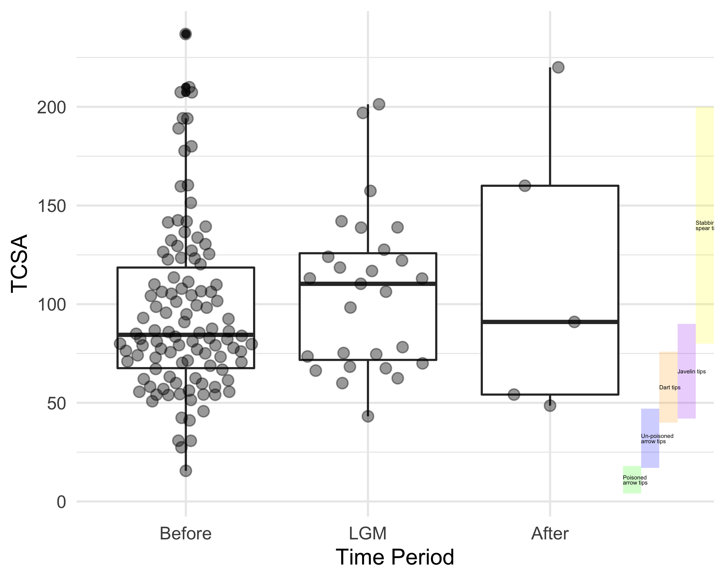

We then grouped stemmed points into three categories based on LGM event: before, LGM, and after to examine possibility of environmental impact on the use of the artifacts (**?@fig-tcsa-radio-carbon-box**). Our results shows that stemmed points were made predominantly before LGM and only a few left after LGM. Each category shows wide variation in LGM, which indicates diverse uses of stemmed points. There is no strong correlation between the TCSA values and the time period (p-value = 0.4).

## Spatial patterns

|  |
| --- |
| Figure 8: Histograms of TCSA values by archaeological site. |

We computed artefact TCSA values for 25 sites that contain more than 160 stemmed points to observe variation between sites (**?@fig-tcsa-per-sites**) Sites with fewer than 160 stemmed points were grouped under the category of ‘other’. Among the sites in our sample, Suyanggae has the most stemmed points and the widest range of TCSA values. This suggests that people made stemmed points for a variety of different purposes in Suyanggae. The TCSA values for Nosanri and Sibuk are have a narrower range of lower values, which indicates less diverse functions for stemmed points. Wolpyeng and Yongsujaeul have similar amounts of stemmed points to Nosanri and Sibuk, but exhibit wider distributions of TCSA values. Yongsandong has the second most stemmed points and TCSA shows a similar distribution to Yongsakul.

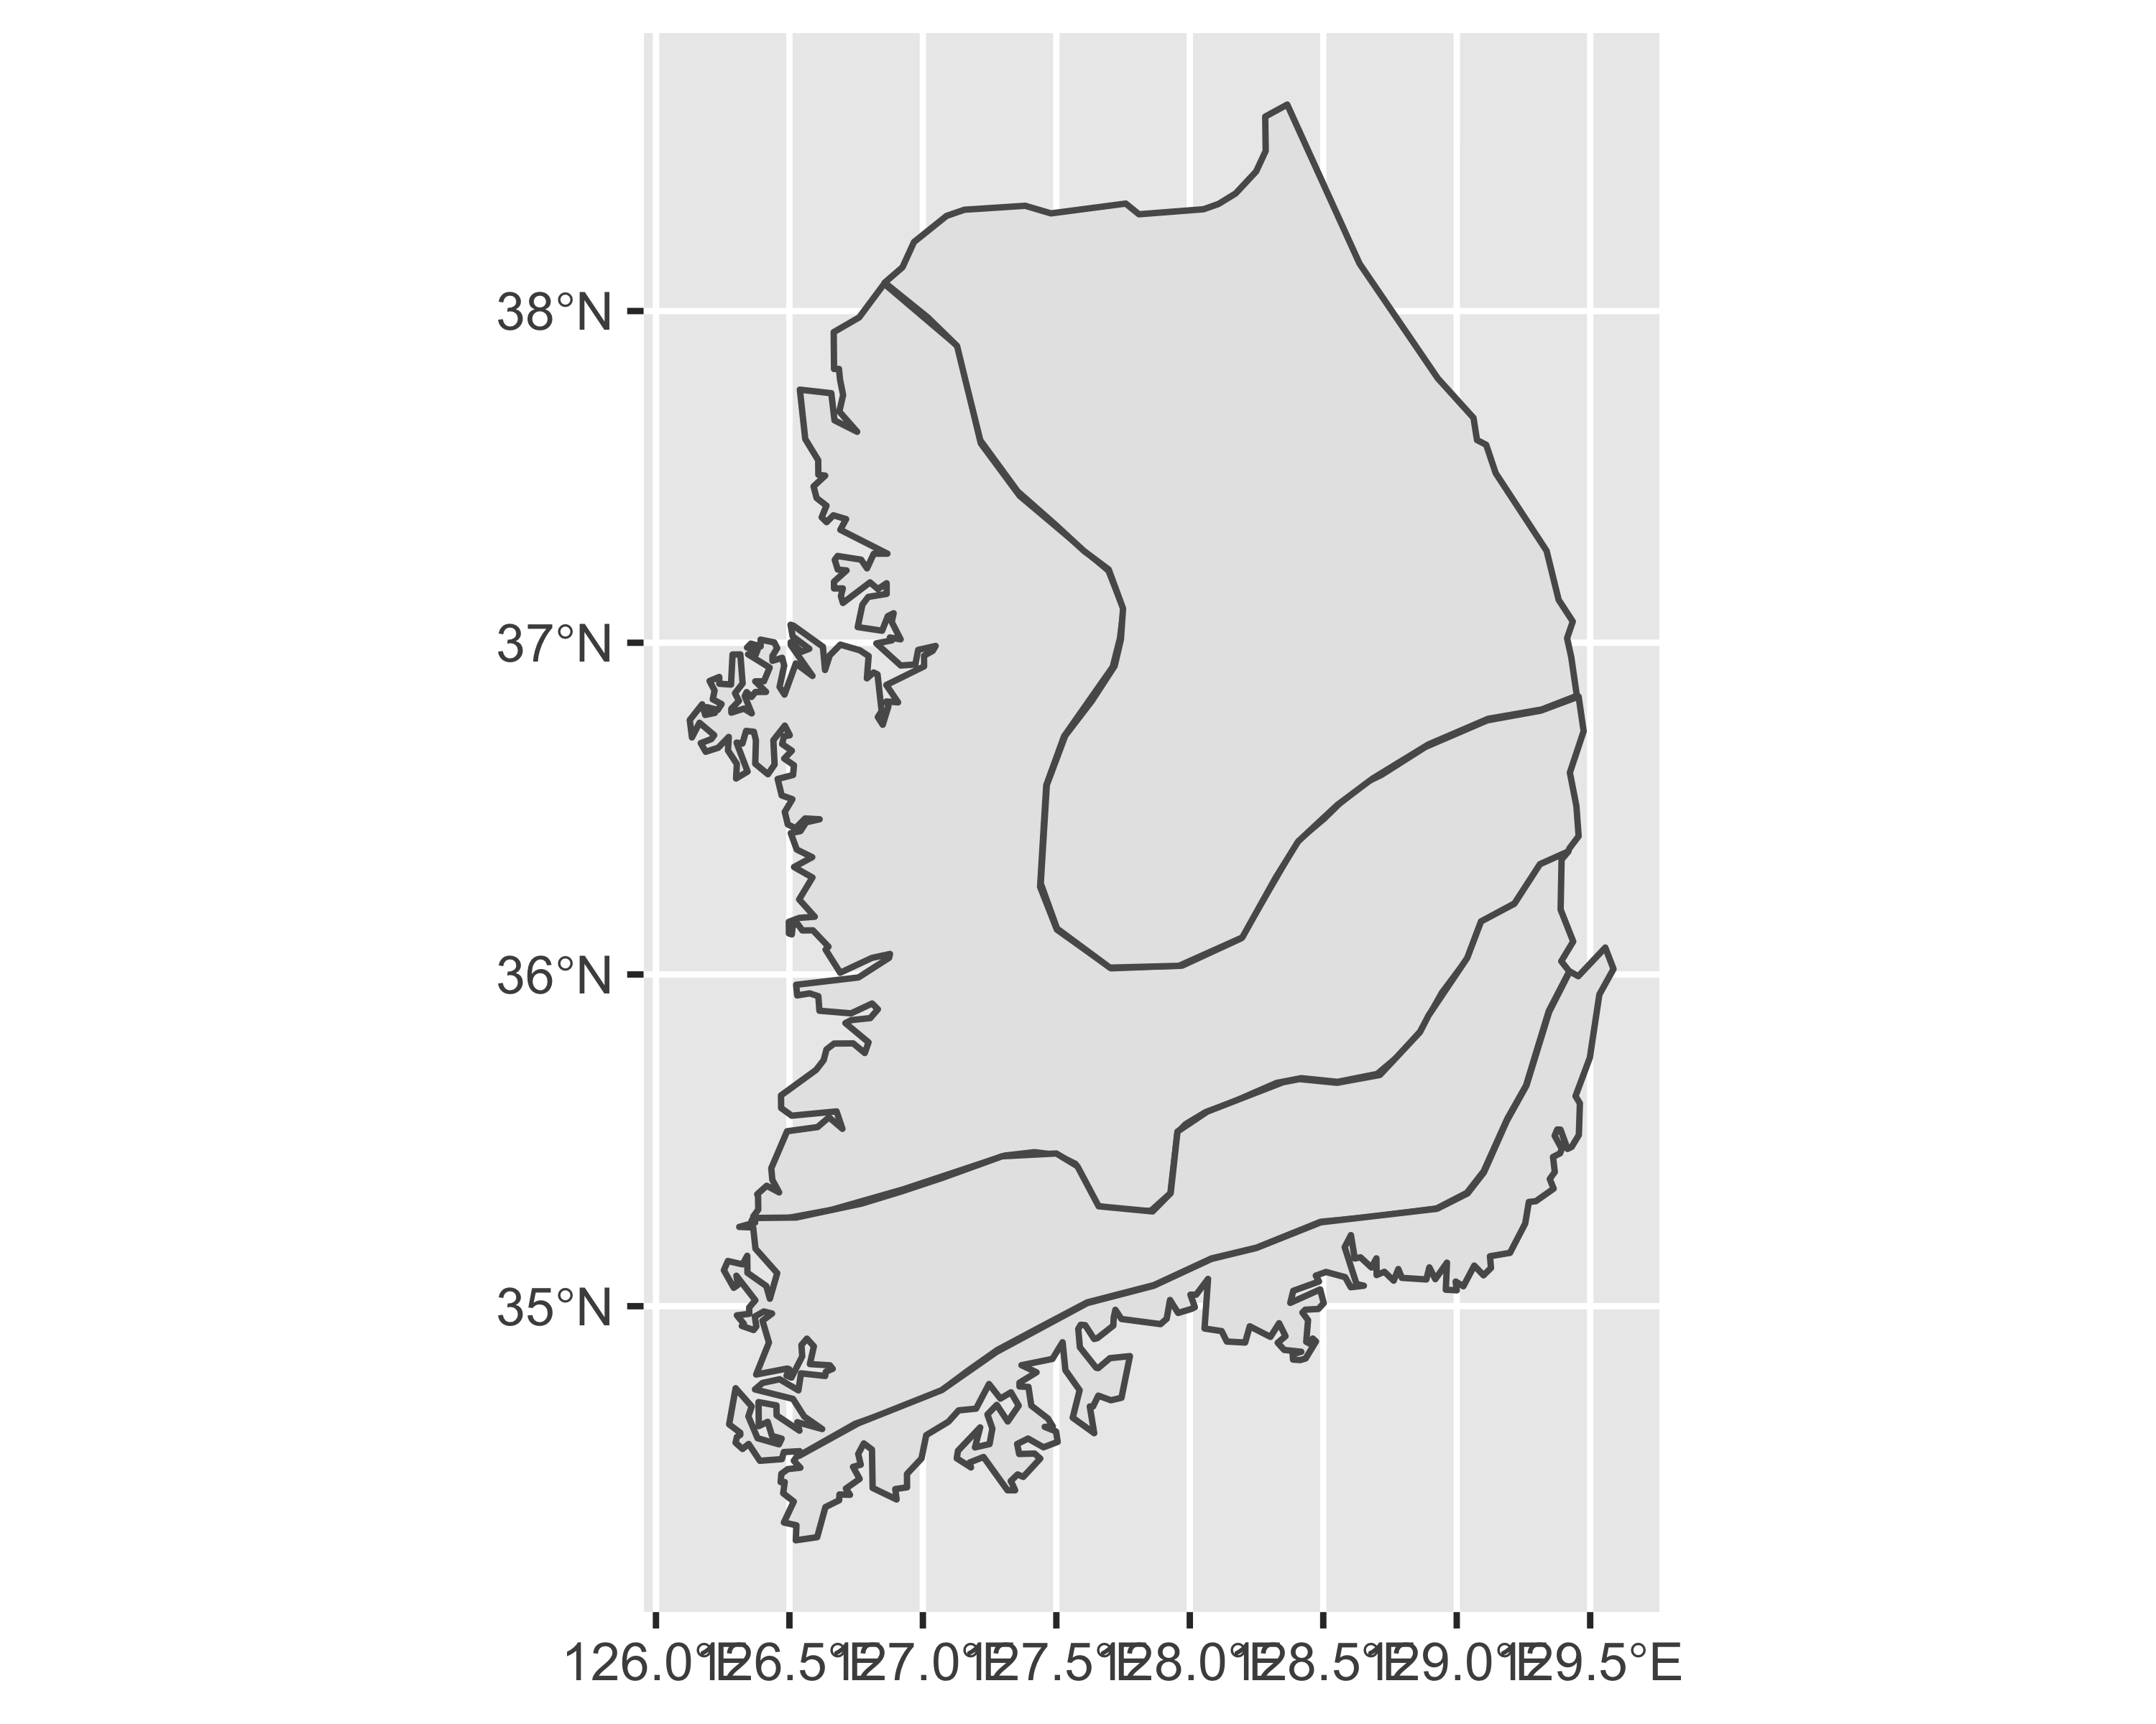

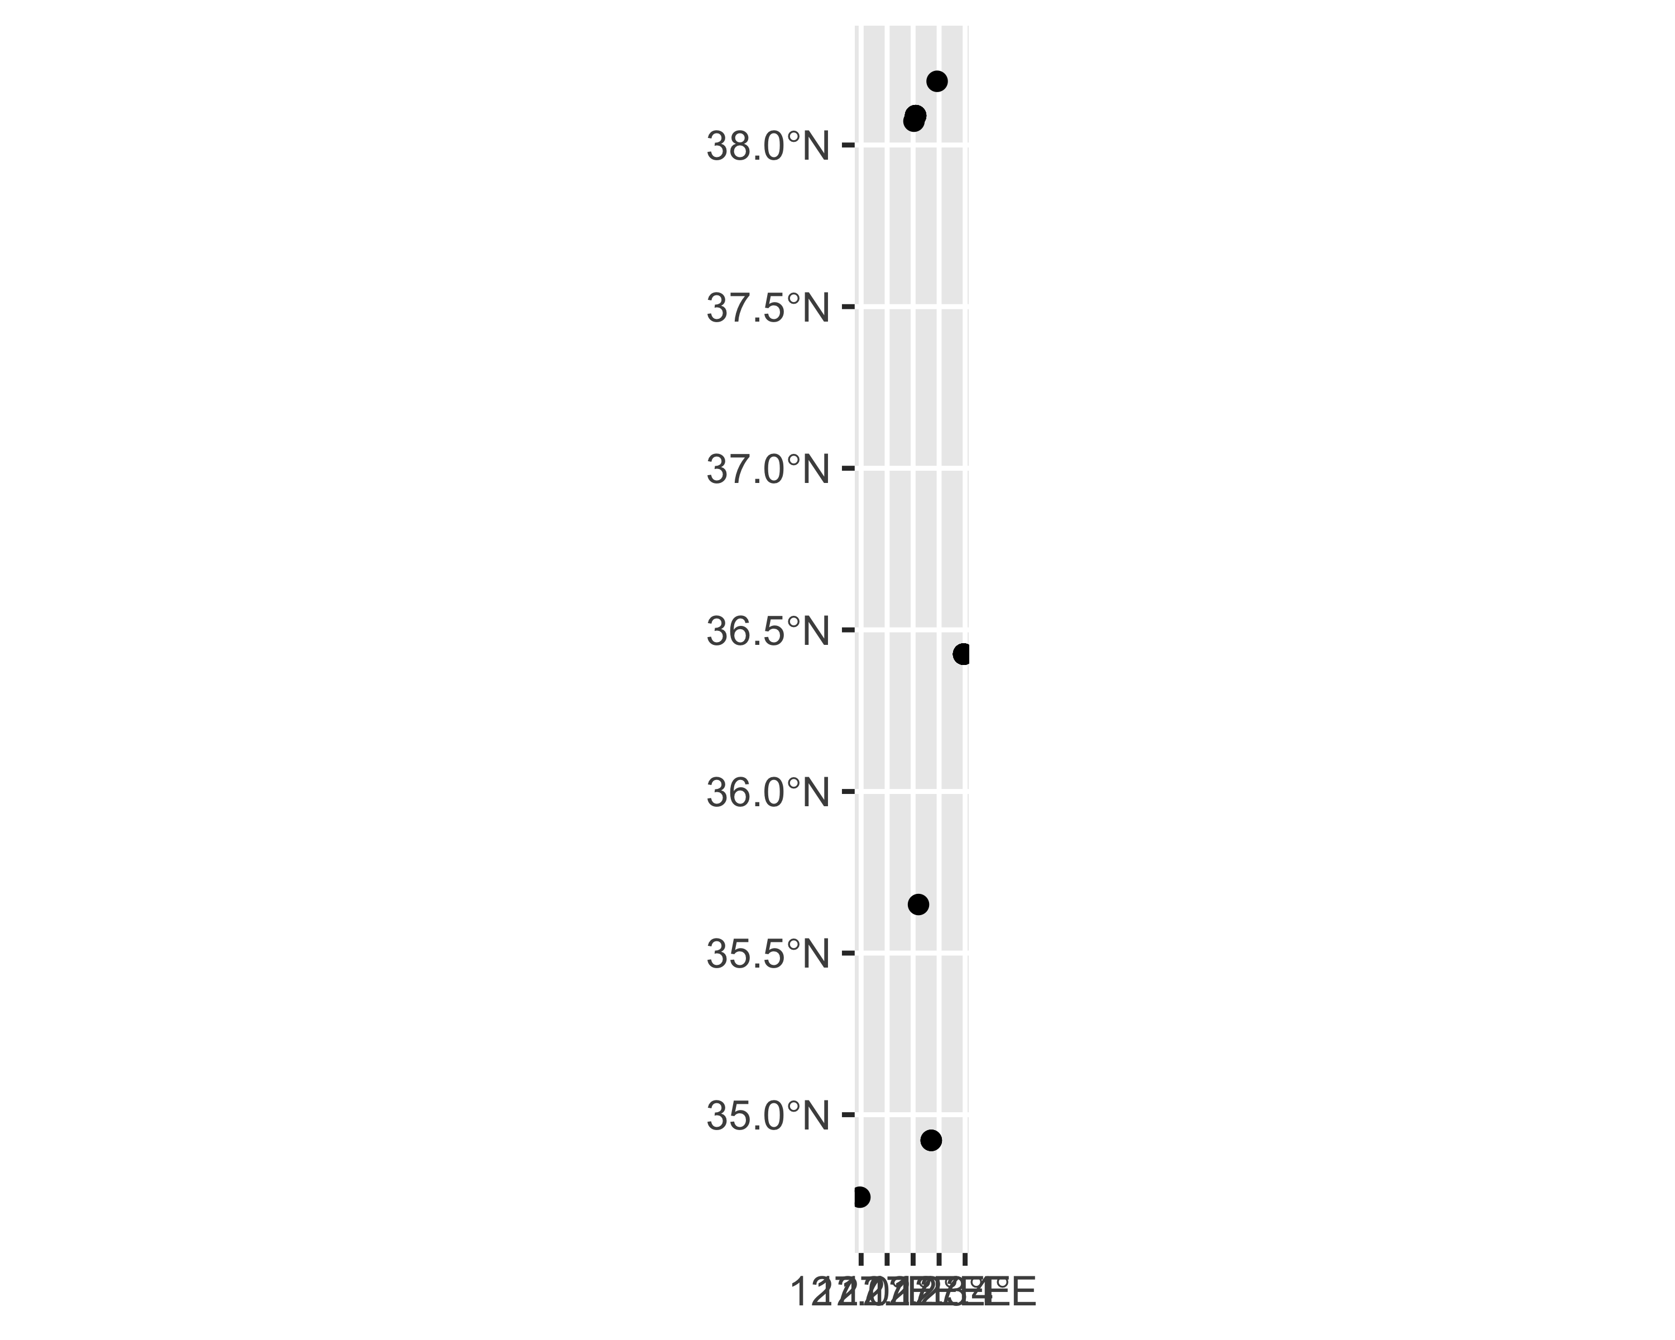

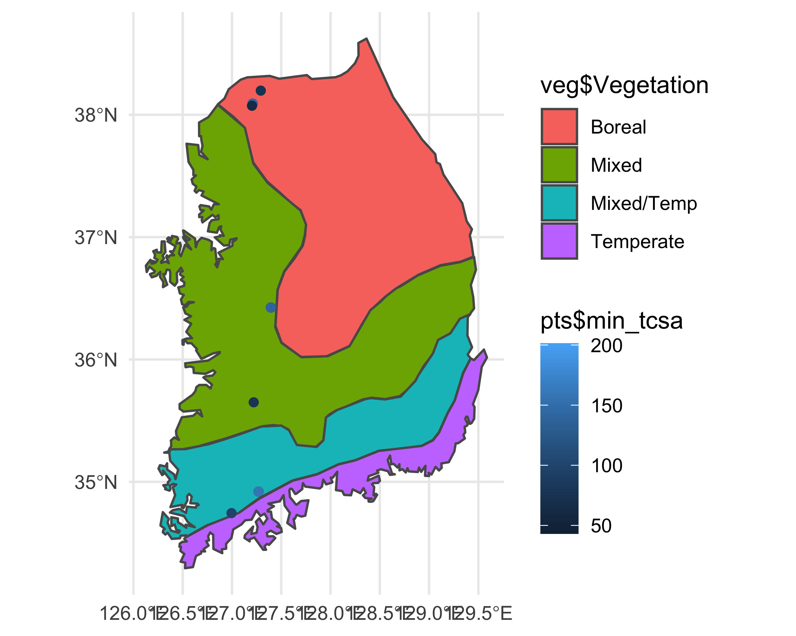

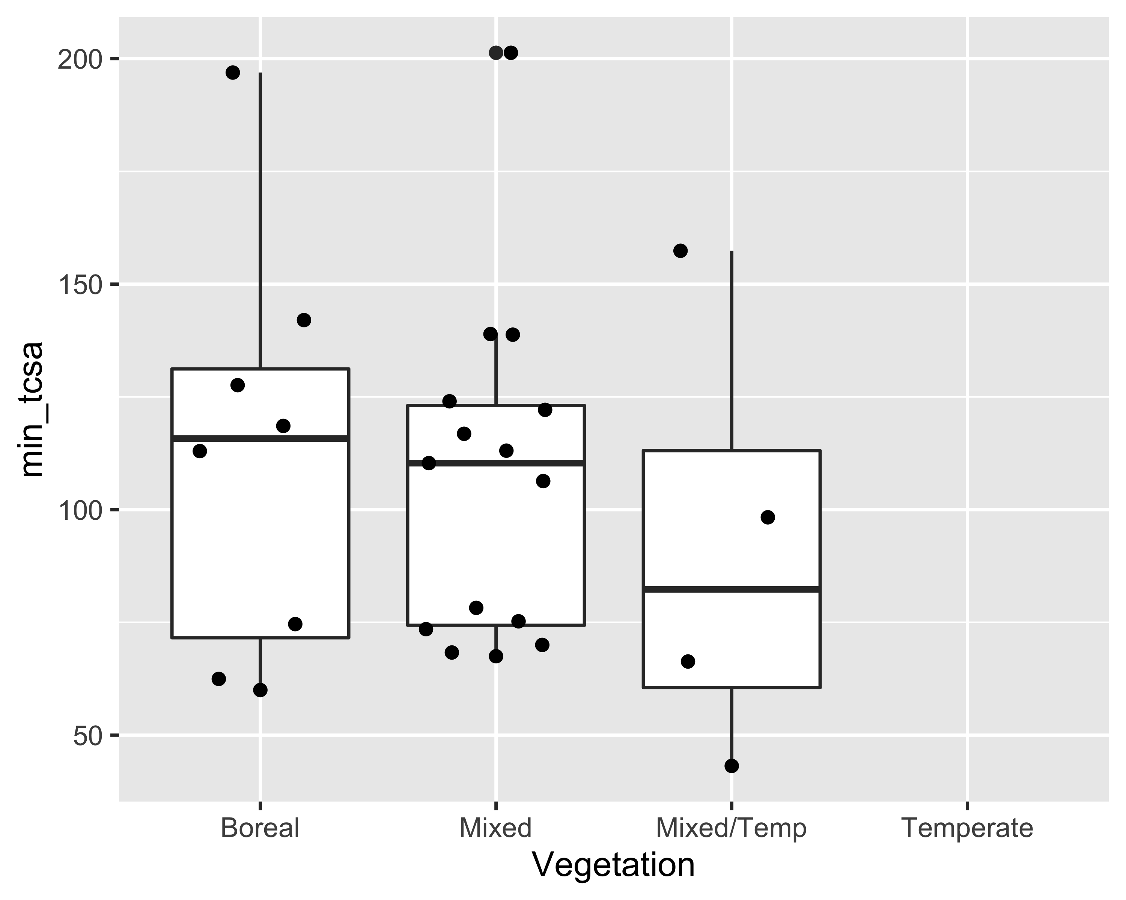

Df Sum Sq Mean Sq F value Pr(>F)  
as.factor(Vegetation) 2 1156 578.2 0.336 0.718  
Residuals 24 41286 1720.3   
1 observation deleted due to missingness

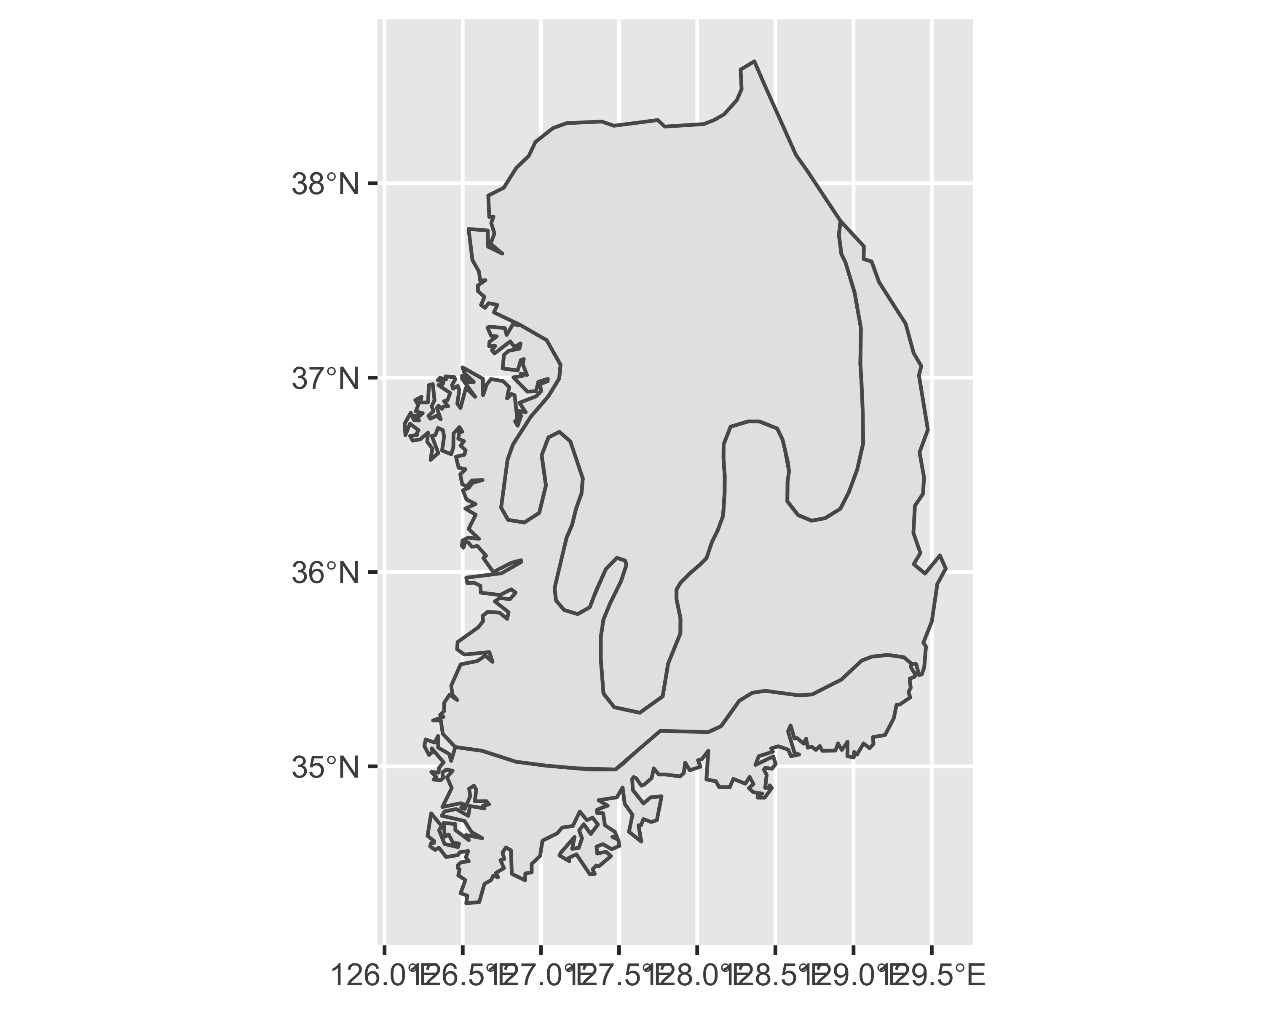

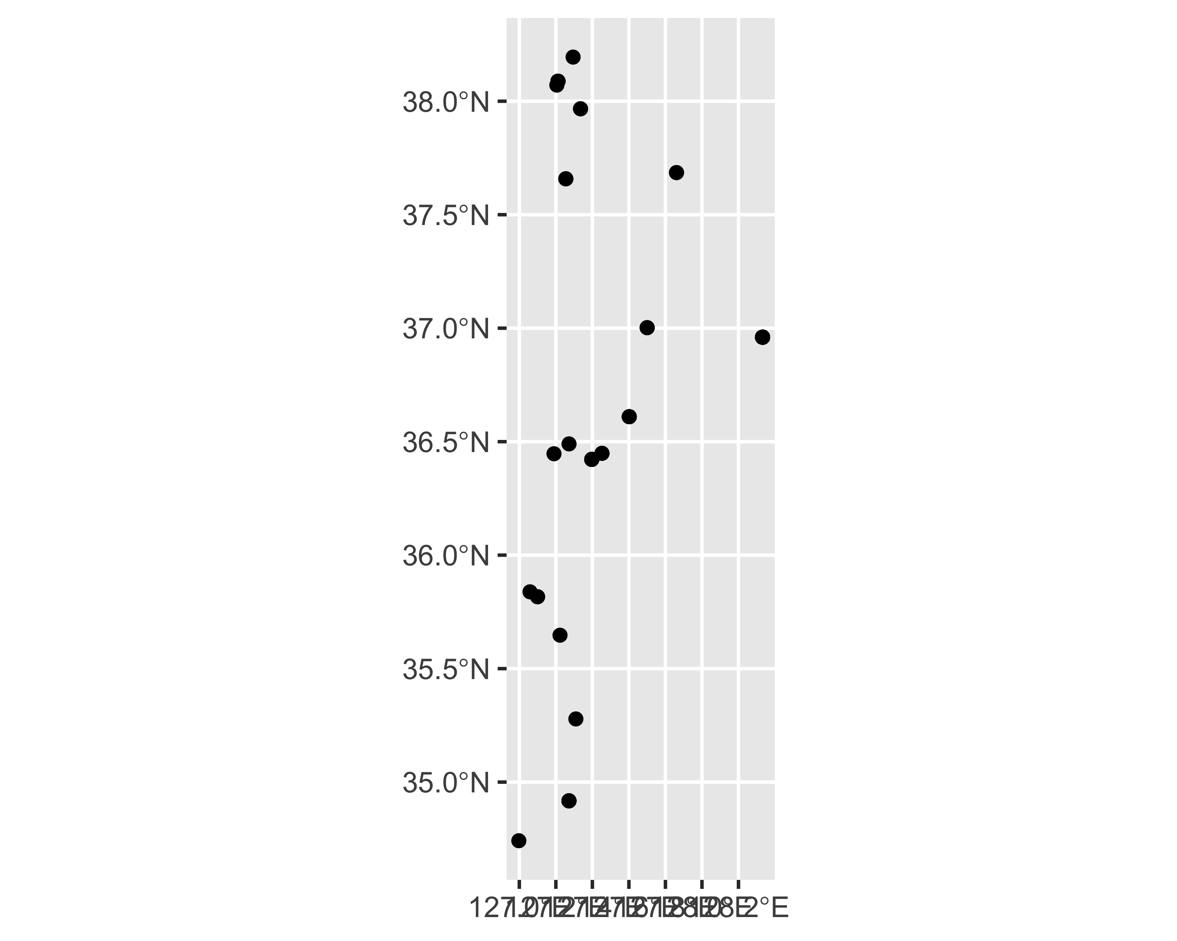

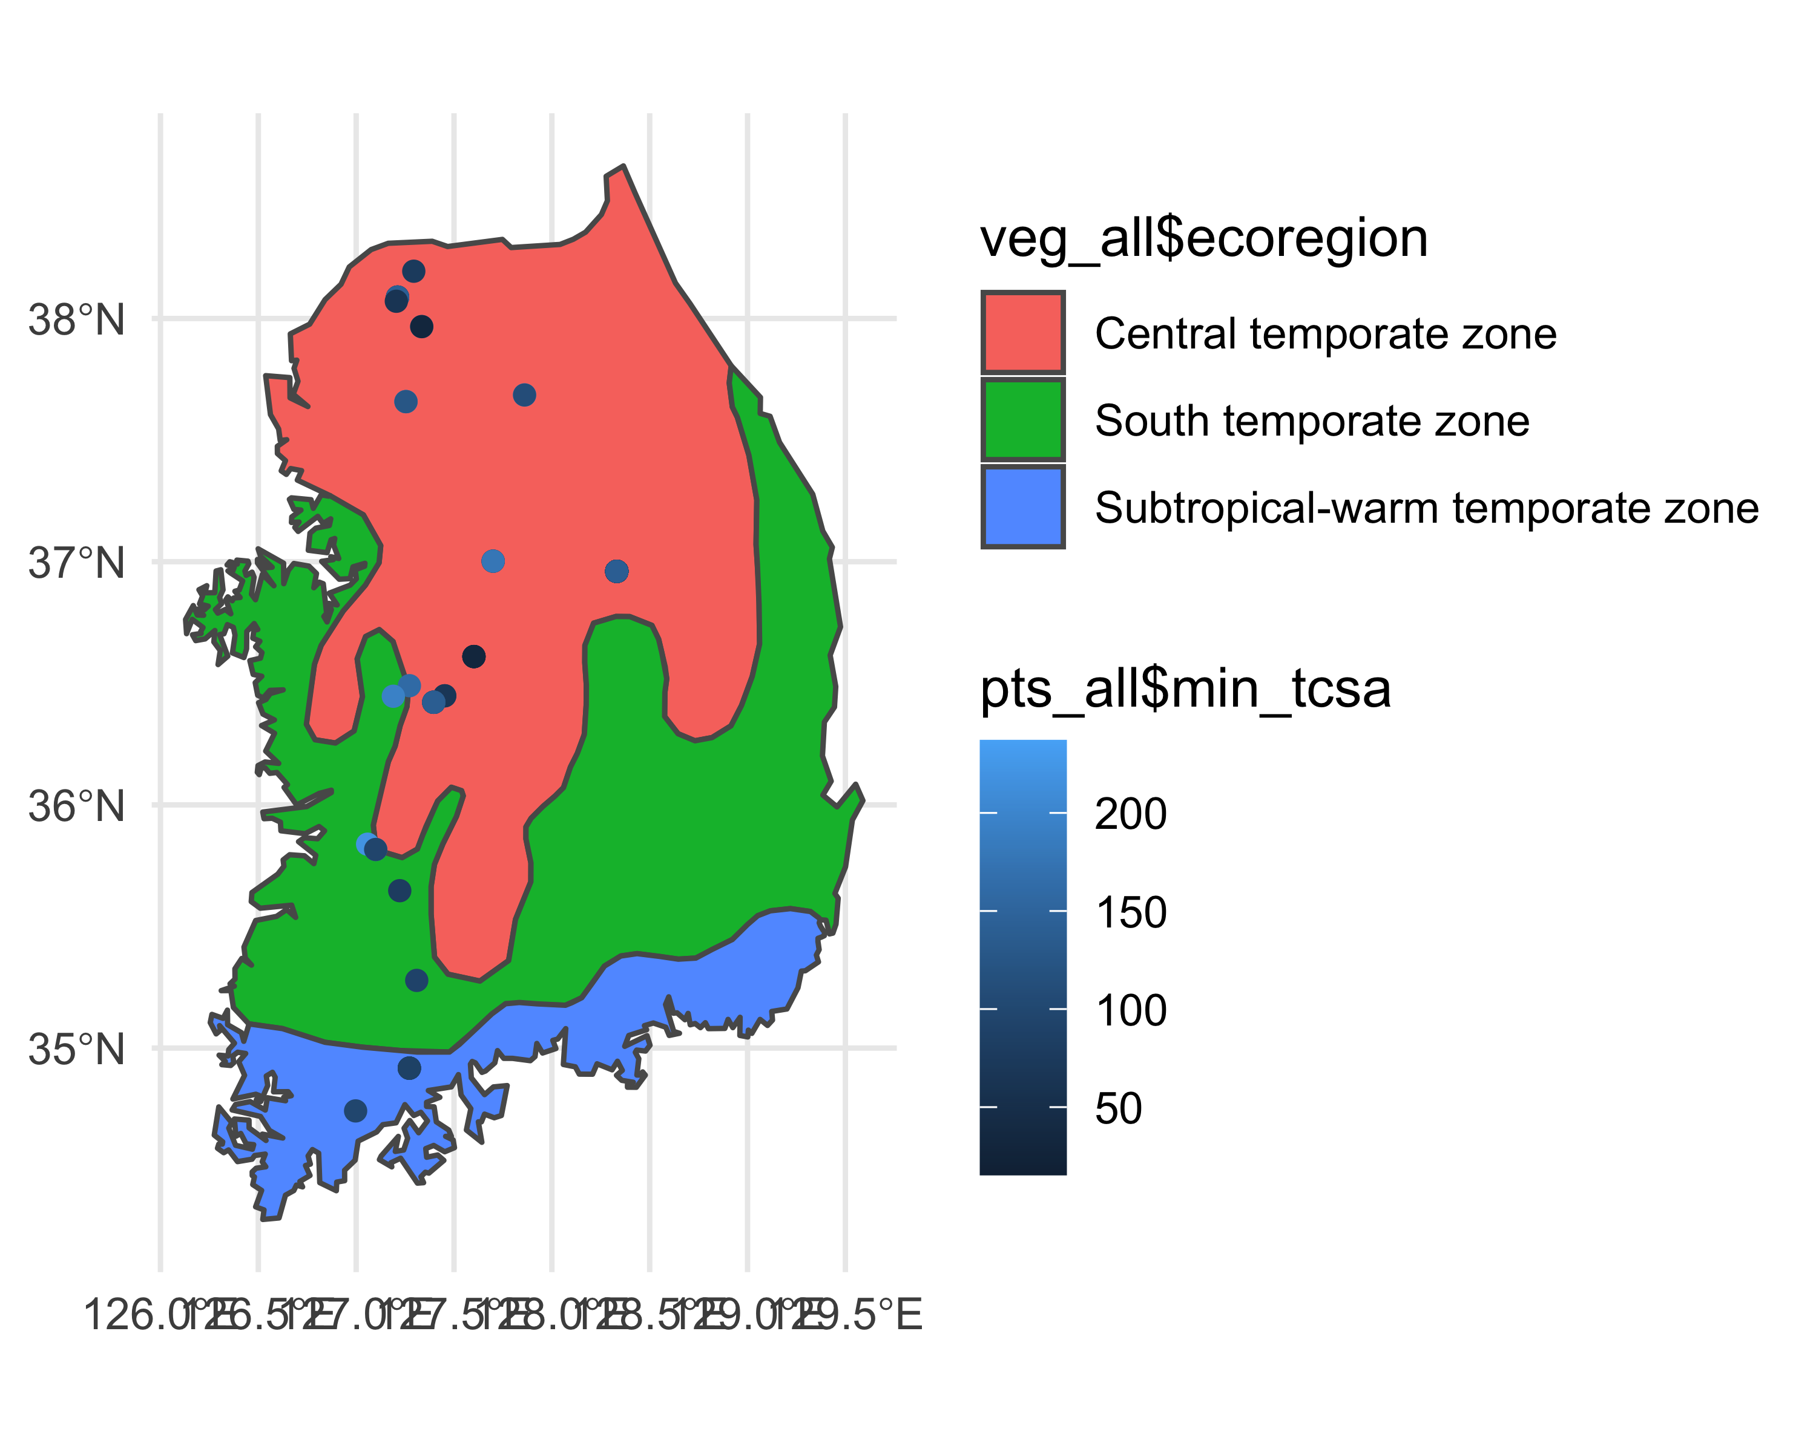

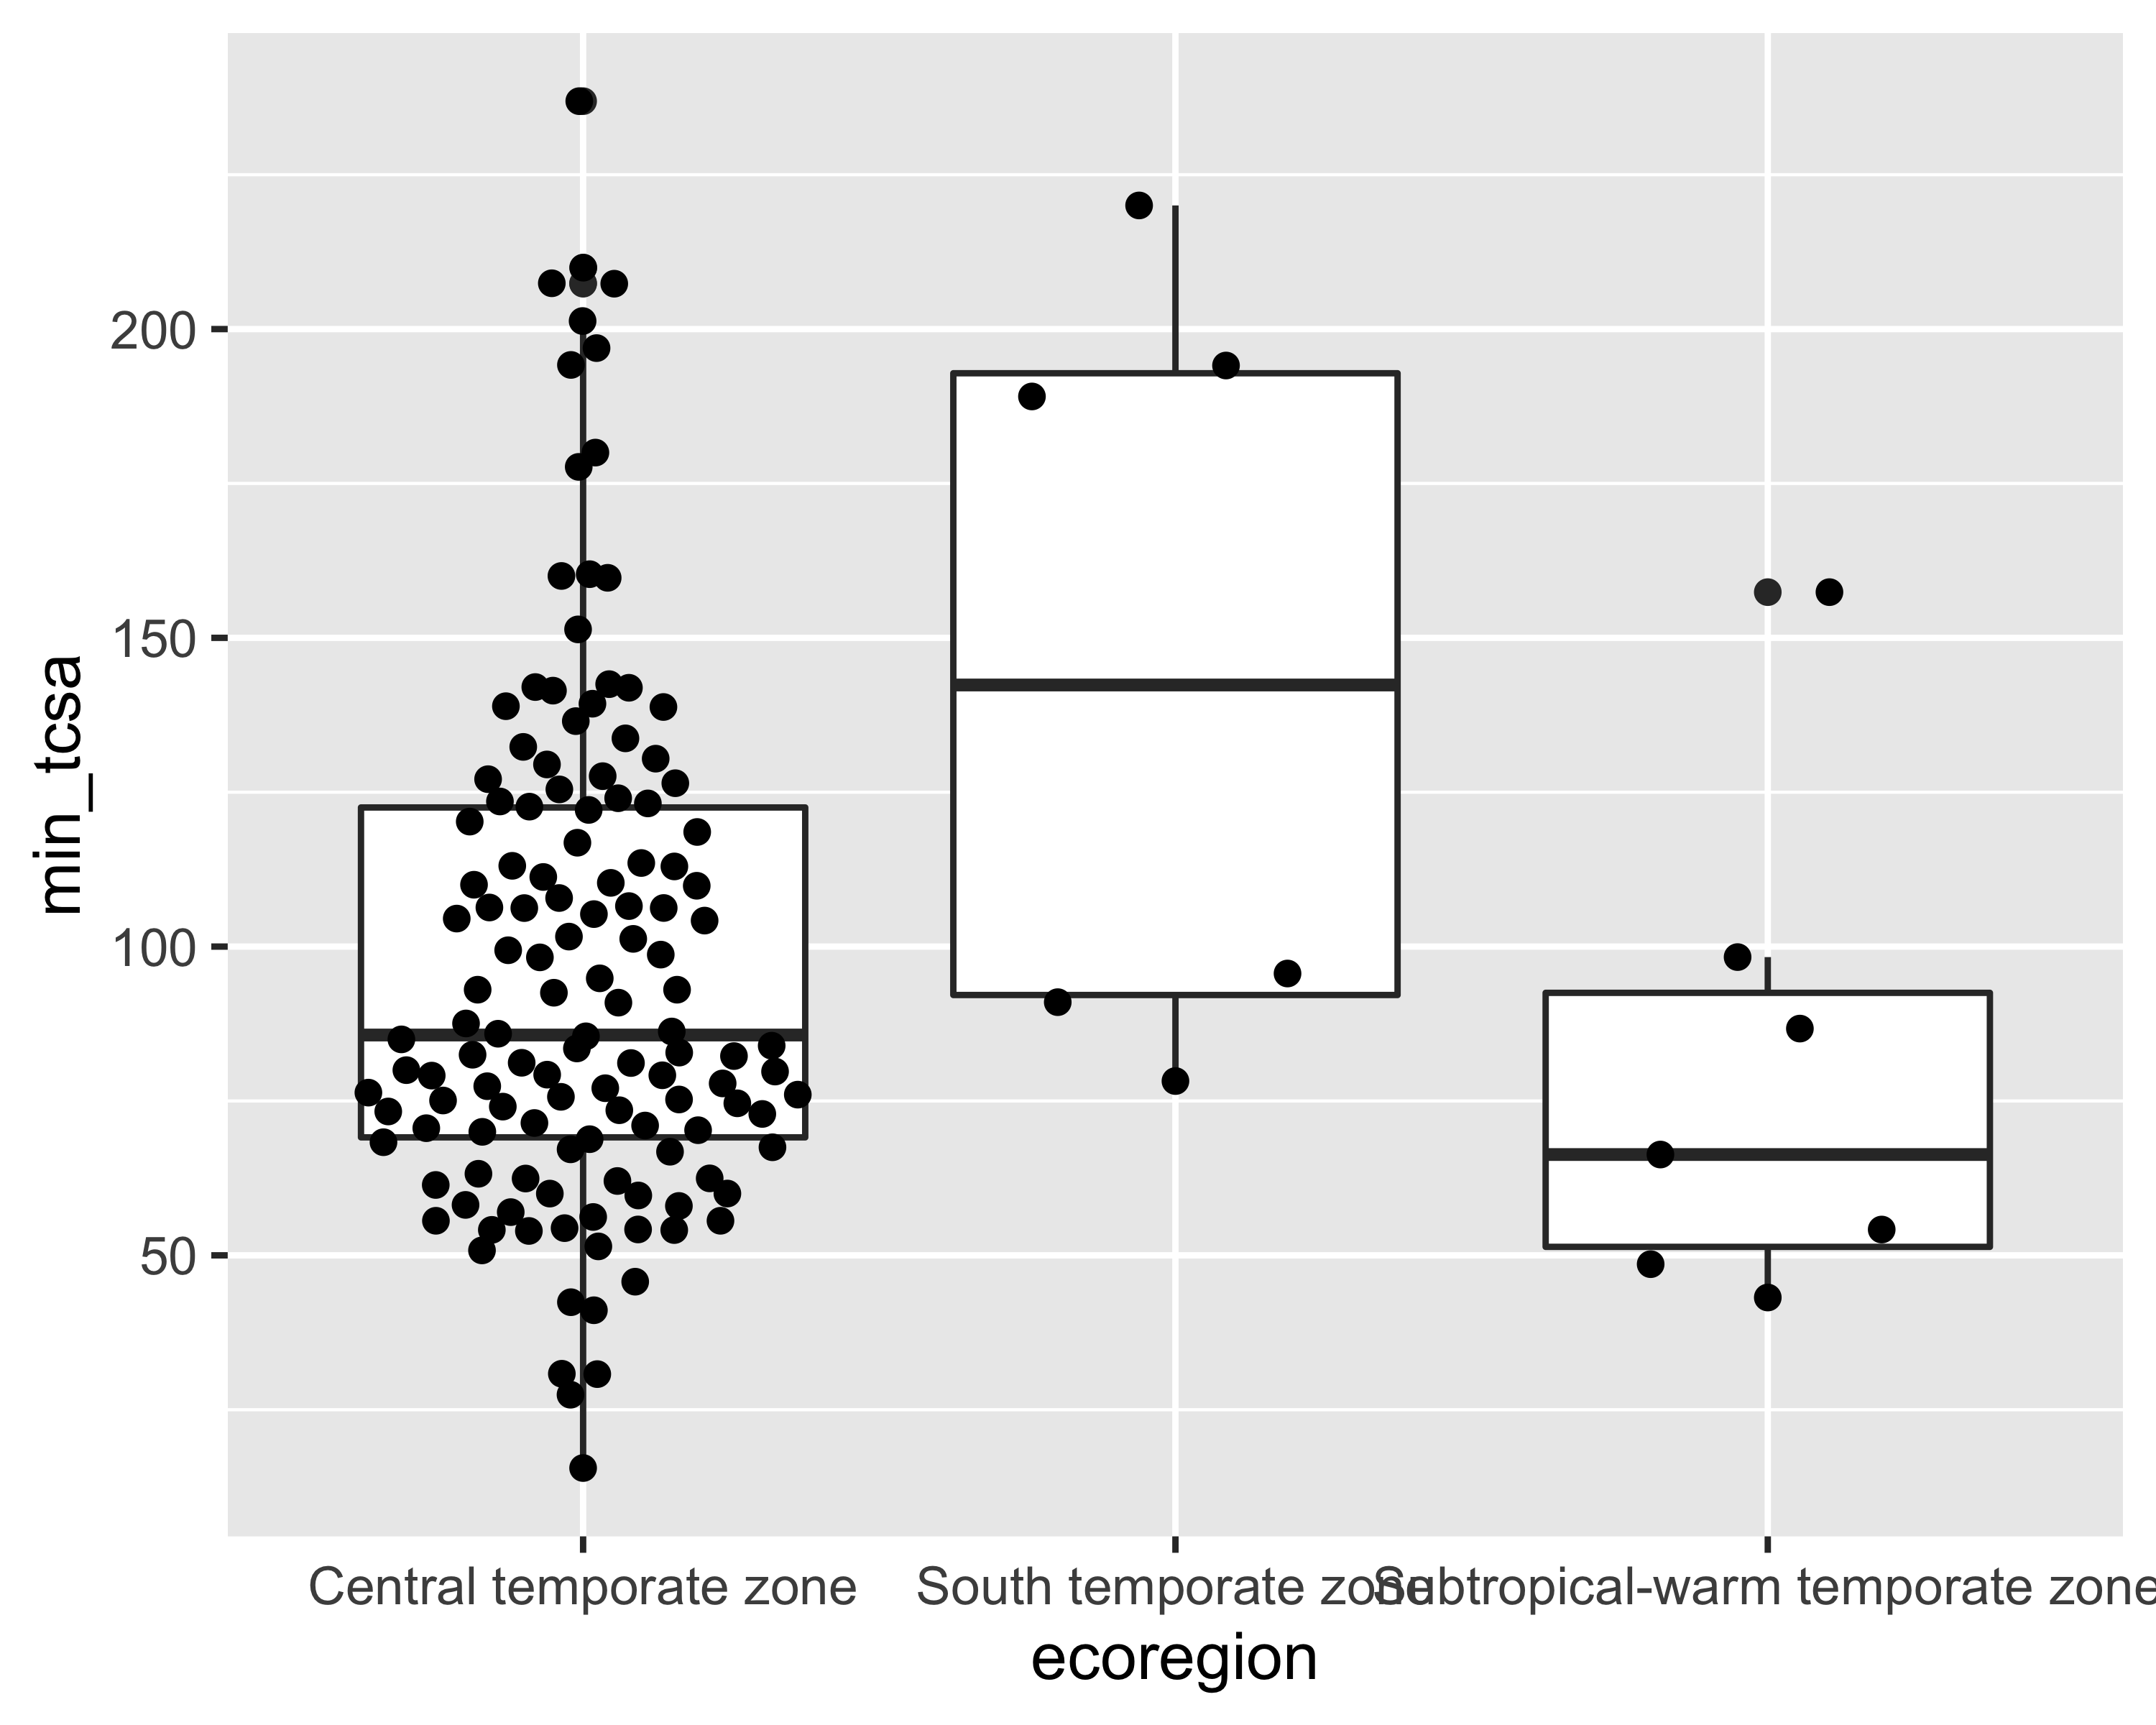

Df Sum Sq Mean Sq F value Pr(>F)   
as.factor(ecoregion) 2 15522 7761 4.266 0.0159 *  
Residuals 140 254706 1819   
---  
Signif. codes: 0 '***' 0.001 '**' 0.01 '*' 0.05 '.' 0.1 ' ' 1

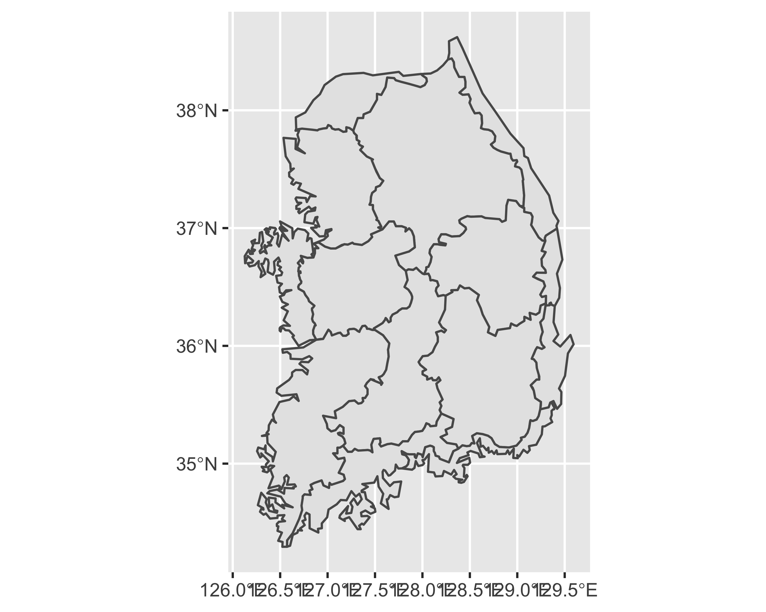



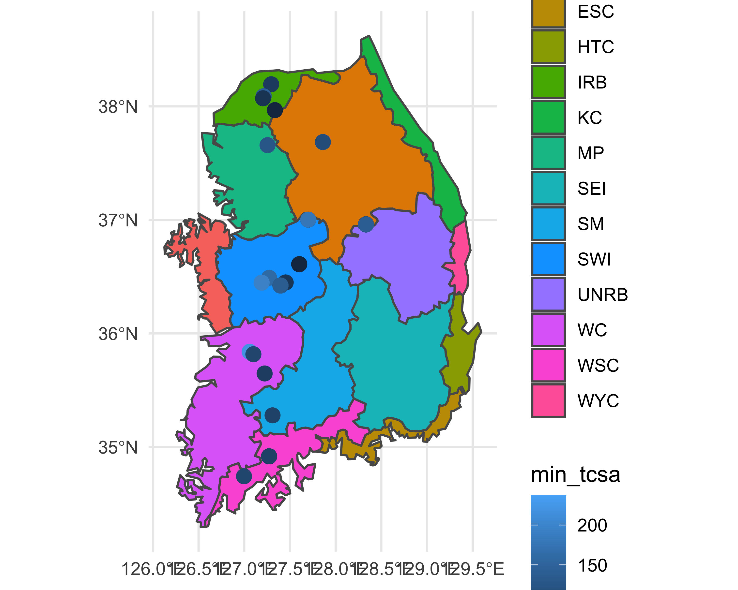

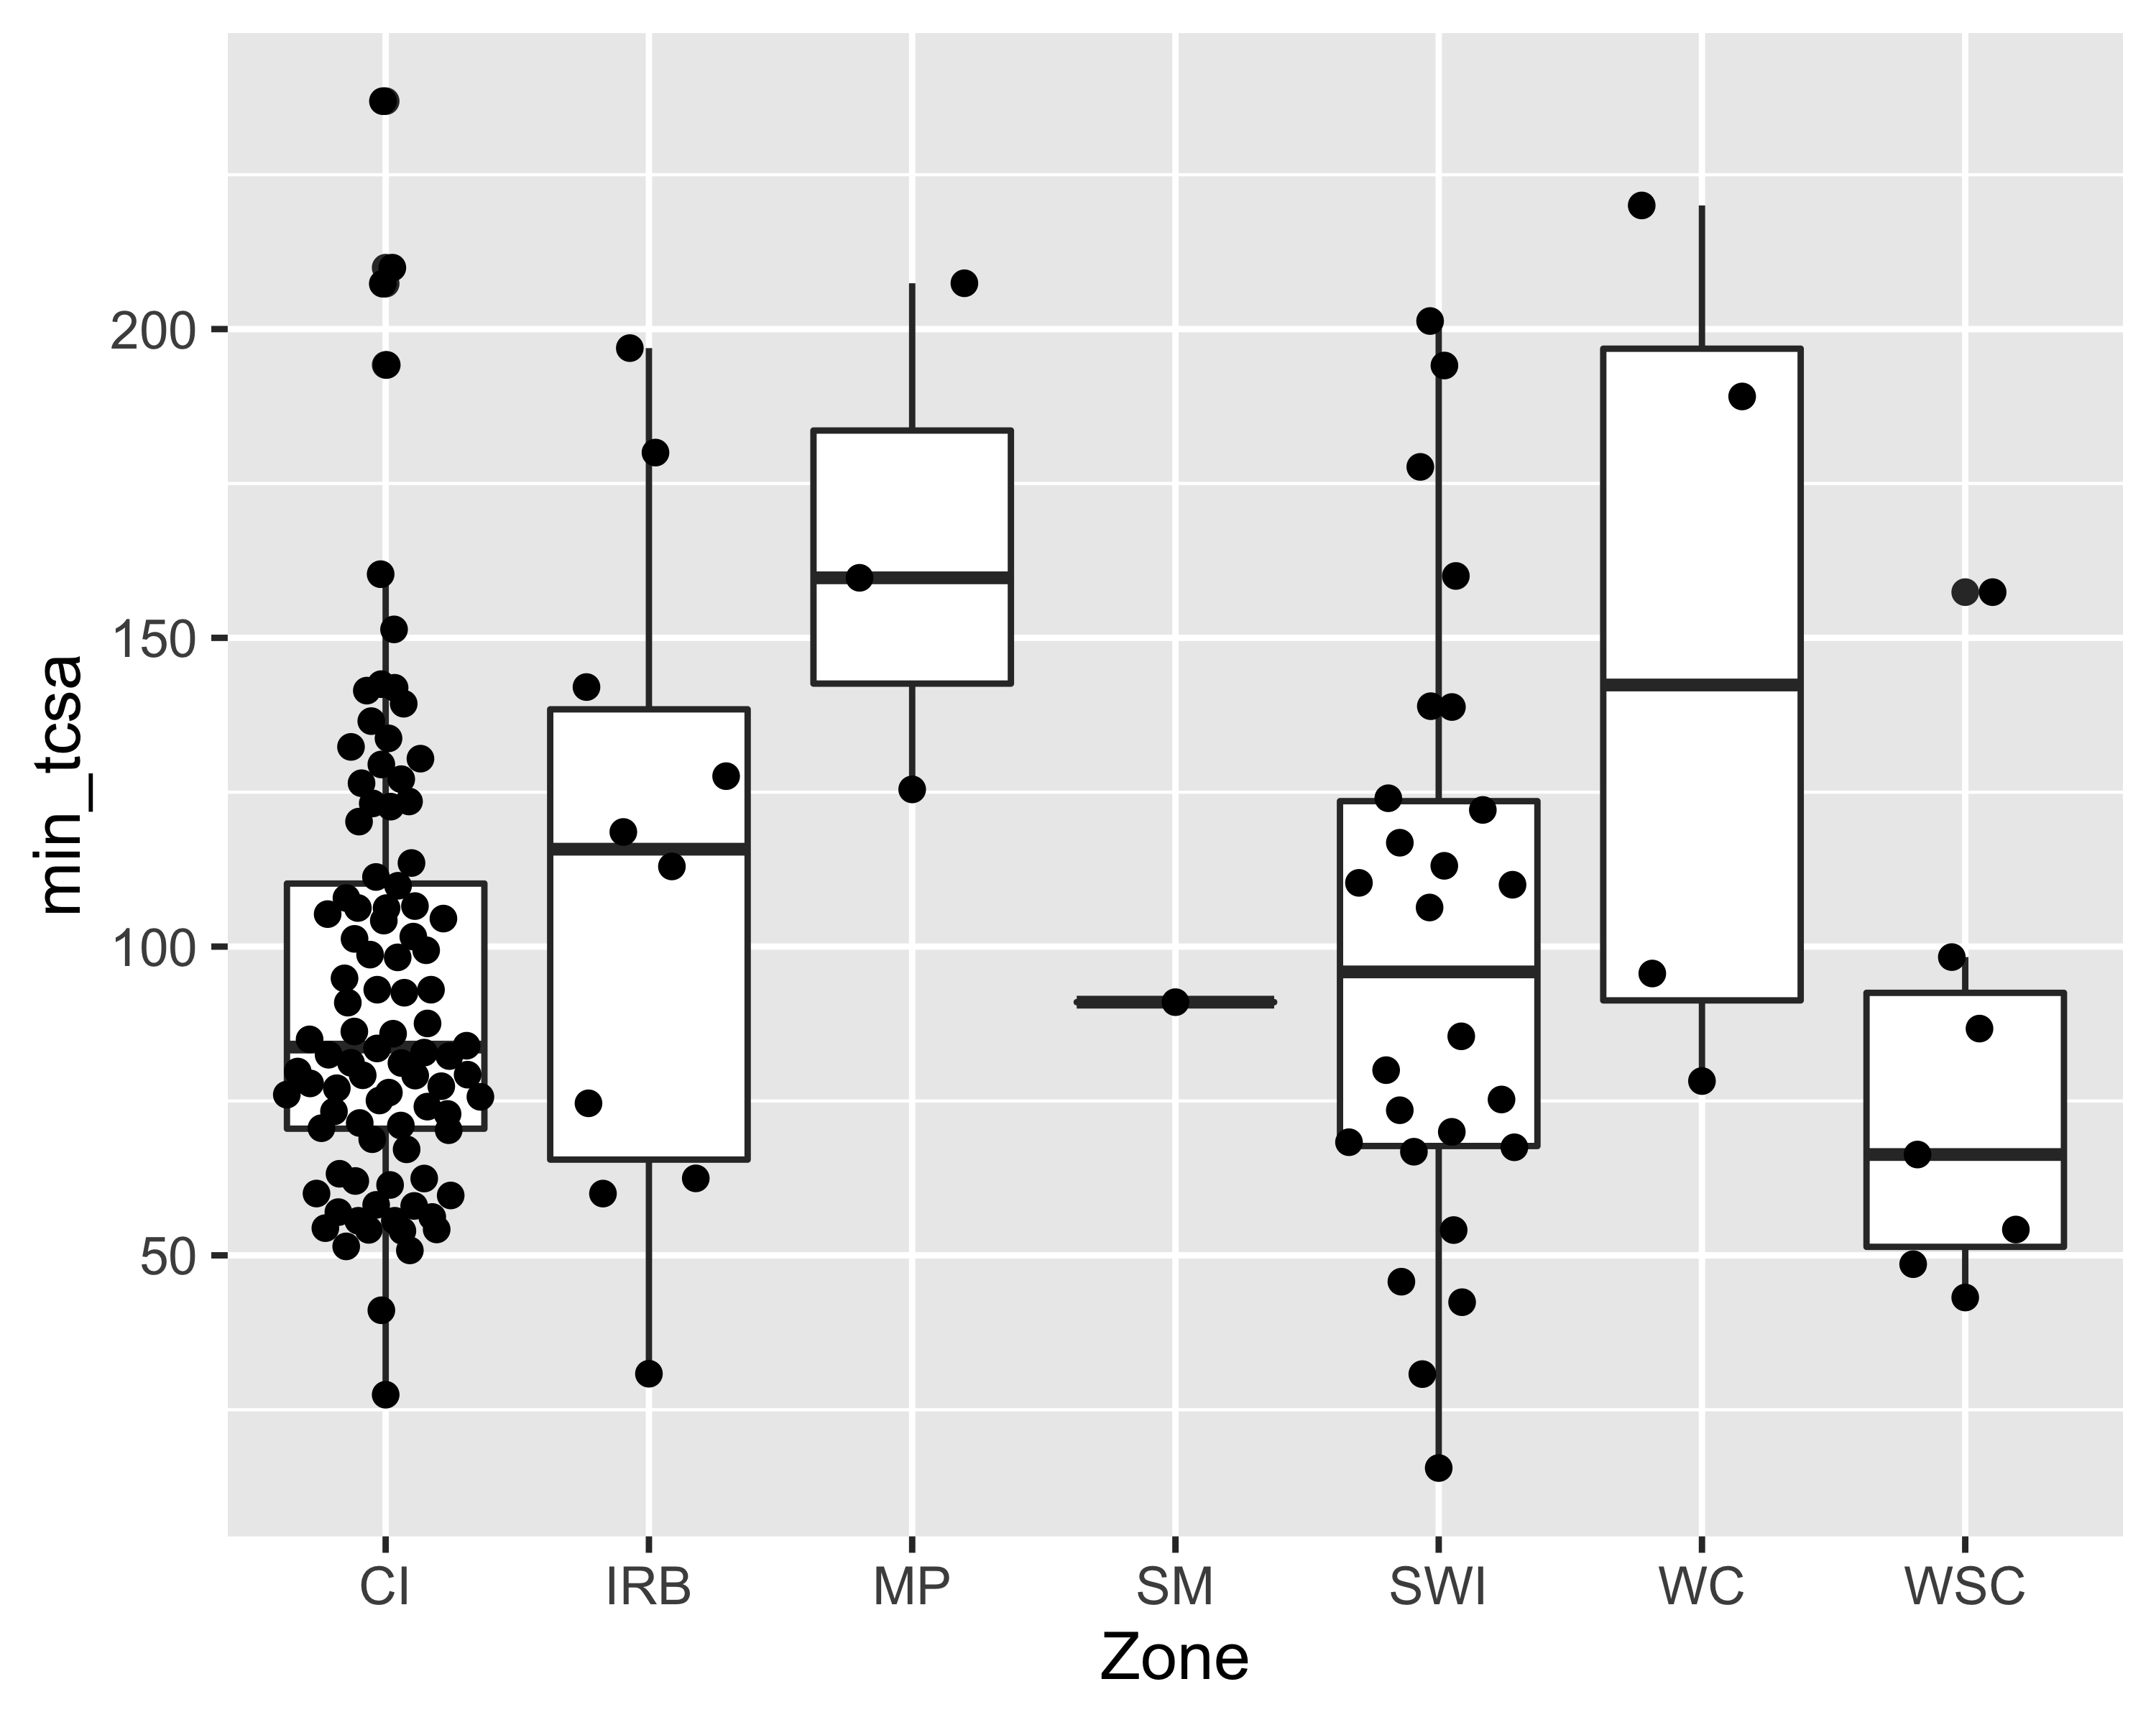

Df Sum Sq Mean Sq F value Pr(>F)   
as.factor(Zone) 6 27600 4600 2.578 0.0213 *  
Residuals 136 242628 1784   
---  
Signif. codes: 0 '***' 0.001 '**' 0.01 '*' 0.05 '.' 0.1 ' ' 1

# Discussion ORDER OF TOPICS HERE MUST FOLLOW EXACTLY THE ORDER OF THE METHODS AND RESULTS SECTION

To investigate the role that stemmed points played in the technological transition during the Korean Late Paleolithic, we computed the TCSA metric to infer likely artifact uses by comparing the results to other archaeological and ethnographic studies Our main questions were: What were the best-fit ballistic probabilities for the stemmed points if they were hafted as weapon tips? How diverse were their likely uses? What are the temporal and spatial patterns in stemmed point uses?

Our results indicate that javelin tips and stabbing spear tips are the most probable ballistic uses for stemmed points. There are a few stemmed points in our sample that may have been used as dart tips and un-poisoned arrow tips, but none of them have TCSA values in the range of poison arrow tips (Figure 3). We found a wide range of TCSA values in our sample, indicating that stemmed points played a diverse role in forager toolkits. Some sites, such as Nosanri and Sinbuk, likely used stemmed points as restricted-function tools. Meanwhile, stemmed points were used for a wider set of tasks at other sites, especially Suyanggae. In general, stemmed points played multiple roles in more sites (Figure 8). Through the Late Paleolithic period, TCSA values showed little directional change (Figure 7). The chronological sequence of TCSA varies from region to region with no clear pattern. Most stemmed points appear to be have designed for use as javelin and stabbing spear tips, but there are also large numbers of tools that likely could fulfill multiple roles as armatures.

TCSA can, however, be impacted by other factors such as raw materials and portability. -Eren et al. (2022) explain that smaller TCSA could be the result of pursuing production economy and transport efficiency. We explore the relationship between TCSA and raw material types and weight in order to examine these factors. Weight plays an important role in portability and penetration of projectiles (Hughes, 1998). According to our results, raw materials do not have a clear pattern, but weight is correlated with raw materials (Figure 4 and Figure 6). Different clusters of weight are matched with different types of weapon tips (Figure 5). Based on these analyses, we assume that people were able to produce the ideal size tools regardless of raw materials.

Our models premise that the choice of weapon-tip types reflects the socio-environmental circumstances. To examine the possible connections between the roles of stemmed points and population dynamics or environmental change during the Late Paleolithic period, we compared the temporal pattern of TCSA to results of Summed probability distribution (SPD) and simulated Mean Annual Temperature (MAT) from Park and Marwick (2022). In those two analyses, -Park and Marwick (2022) covered assemblages with and without stemmed points, which is useful for us to explore the overall socio-environmental dynamics. As we discussed, there is no clear pattern in the temporal or regional pattern of TCSA (Figure 7 or (**no-figure-no-more?**): A). We consider that TCSA, or the function of the stemmed points, are strongly dependent on the surrounding environment or their situation. (**no-figure-no-more?**): B shows that the temperature slowly decreased until around 22 ka and then went up again with a little range of fluctuations. Temperatures differ significantly between sites, with a maximum difference of 5℃. Results of SPD show several peaks, as indicated by the positive deviations from the three null models (shaded in red), and downs (shaded in blue), but no drastic growth or decline ((**no-figure-no-more?**): C). From the climate and population study, we could observe that there is no dominating change but minor and often fluctuations throughout the Late Paleolithic and variations per site. Overall this pattern is well matched with the TCSA results, indicating the people produced stemmed points as multifunctional tools suitable for unexpected or various situations in their habitats similar to the case of Clovis points (Eren et al. (2022)).

<–! In discussion we then compare those temporal patterns with demographic and environmental proxies based on summed probability distributions (SPD) and annual temperature changes from Park and Marwick (2022). –>

Our models premise that the choice of weapon-tip types reflects the socio-environmental circumstances. To examine the possible connections between the roles of stemmed points and population dynamics or environmental change during the Late Paleolithic period, we compared the temporal pattern of TCSA to results of Summed probability distribution (SPD) and simulated Mean Annual Temperature (MAT) from Park and Marwick (2022). In those two analyses, -Park and Marwick (2022) covered assemblages with and without stemmed points, which is useful for us to explore the overall socio-environmental dynamics here. As we previously noted, there is no clear pattern in the temporal or regional pattern of TCSA (Figure 7). THIS DISCUSSION IS INCOMPLETE, WE NEED TO EXPLORE THESE RELATIONSHIPS ABOUT GEOGRAPHICAL VARIATION AND TEMPORAL VARIATION FURTHER, AND IN A NEW WAY THAT IS NOT THE SAME AS THE QSR PAPER, E.G. FOCUS ON THE LGM AS I MENTIONED IN OUR LAST MEETING.

SPATIAL ANAlysis Prates et al. (2022) provde strong relationship between the temporal density and spatial distribution of megafauna and Fishtail projectile points, and proposed that this weapon was designed and used for megafauna hunting, contributing to their extinction by exploring changes in projectile point technology, as well as the body mass of potential megafaunal prey, and show that Fishtails were strongly related to the largest extinct megafaunal species.

# Conclusion

RESTATE QUESTIONS AND ANSWERS VERY BRIELFY

SUGGEST SOME POSSIBLE DIRECTIONS FOR FUTURE WORK, E.G. EXPERIMENTAL ARCHAEOLOGY, USEWEAR ANALYSIS

We are aware of the arbitrary that discriminating the function of small projectile points could be arbitrary work (Erlandson et al., 2014). Because TCSA covers the critical elements of projectiles, flight and penetration dynamics (i.e. increased or decrease by shape of tip and cross section), we consider it a useful metric for discriminating between weapon tip functions (Hughes, 1998; Lombard, 2021; Sitton et al., 2020). Stemmed points have been considered so far as long-distance hunting amateurs pursuing large bodies of prey such as a deer (Chang, 2013; Lee and Sano, 2019; Lee and Jang, 2011a; Lee and Kong, 2002a; Seong, 2008). TCSA enabled us to gain a more detailed understanding of the function of stemmed points.

# Acknowledgements

# CRediT authorship contribution statement

Gayoung Park: Software, Validation, Formal analysis, Resources, Data curation, Writing - original draft, Writing - Review & Editing, Visualization, Project administration.

Marlize Lombard: Conceptualization, Methodology, Writing - Review & Editing, Supervision

Donghee Chong: Data curation, Review & Editing

Ben Marwick: Software, Validation, Formal analysis, Investigation, Writing - Review & Editing, Visualization, Supervision

# References

Angelbeck, B., Cameron, I., 2014. The faustian bargain of technological change: Evaluating the socioeconomic effects of the bow and arrow transition in the coast salish past. Journal of Anthropological Archaeology 36, 93–109.

Bae, C.J., 2017. Late pleistocene human evolution in eastern asia: Behavioral perspectives. Current Anthropology 58, S514–S526.

Bae, C.J., Douka, K., Petraglia, M.D., 2017. On the origin of modern humans: Asian perspectives. Science 358, eaai9067.

Bae, K., 2010. Origin and patterns of the upper paleolithic industries in the korean peninsula and movement of modern humans in east asia. Quaternary International 211, 103–112.

Bettinger, R.L., 2013. Effects of the bow on social organization in western north america. Evolutionary Anthropology: Issues, News, and Reviews 22, 118–123.

Bettinger, R.L., Grote, M.N., 2016. Marginal value theorem, patch choice, and human foraging response in varying environments. Journal of Anthropological Archaeology 42, 79–87.

Bird, D.W., O’Connell, J.F., 2006. Behavioral ecology and archaeology. Journal of Archaeological Research 14, 143–188.

Chang, Y., 2013. Human activity and lithic technology between korea and japan from MIS 3 to MIS 2 in the late paleolithic period. Quaternary International 308, 13–26.

Chang, Y., 2002. The study on pointed stone tools in korea. Journal of Korean Paleolithic Society 37–46.

Chong, D., 2021. Tanged point morphology and behavioral diversity of the upper paleolithic assemblages in korea (Master’s Thesis). Department of History, Kyung Hee University, Seoul (in Korea).

Core, R., 2021. Team. R: A language and environment for statistical computing, 2015.

Eren, M.I., Bebber, M.R., Knell, E.J., Story, B., Buchanan, B., 2022. Plains paleoindian projectile point penetration potential. Journal of Anthropological Research 78, 84–112.

Erlandson, J.M., Watts, J.L., Jew, N.P., 2014. Darts, arrows, and archaeologists: Distinguishing dart and arrow points in the archaeological record. American Antiquity 79, 162–169.

Fenenga, F., 1953. The weights of chipped stone points: A clue to their functions. Southwestern Journal of Anthropology 9, 309–323.

Hughes, S.S., 1998. Getting to the point: Evolutionary change in prehistoric weaponry. Journal of Archaeological Method and Theory 5, 345–408.

Kelly, R.J., 2007. The foraging spectrum: Diversity in hunter-gatherer lifeways. ISD LLC.

Kim, E., n.d. Morphological diversity and functional differentiation of tanged-points: Focused on suyanggae, jingeuneul and yongsandong site. Journal of Korean Paleolithic Society.

Kim, E., 2017. Morphological diversity and functional differentiation of tanged-point: Focused on suyanggae, jingeuneul and yongsandong site. Journal of Korean Paleolithic Society 29–47.

Kim, H.-I., 2004. Yongsan-dong paleolithic site, daejeon. Hanguk Guseoki Hakbo 10, 83–94.

Kim, J.C., Chang, Y., 2021. Evidence of human movements and exchange seen from curated obsidian artifacts on the korean peninsula. Journal of Archaeological Science: Reports 39, 103184.

Lee, G., 2015. The characteristics of upper paleolithic industries in korea. Emergence and diversity of modern human behavior in Paleolithic Asia 270–286.

Lee, G., 2012. Characteristics of paleolithic industries in southwestern korea during MIS 3 and MIS 2. Quaternary International 248, 12–21.

Lee, G.-K., Sano, K., 2019. Were tanged points mechanically delivered armatures? Functional and morphometric analyses of tanged points from an upper paleolithic site at jingeuneul, korea. Archaeological and Anthropological Sciences 11, 2453–2465.

Lee, H.-J., Jang, D., 2011b. A study on the function and restoration of tanged tools in the upper palaeolithic of korea. Journal of the Korean Palaeolithic Society 23, 103–120.

Lee, H.-J., Jang, D., 2011a. A study on the function and restoration of tanged tools in the upper palaeolithic of korea. Journal of the Korean Palaeolithic Society 23, 103–120.

Lee, H.W., Bae, C.J., Lee, C., 2017. The korean early late paleolithic revisited: A view from galsanri. Archaeological and Anthropological Sciences 9, 843–863.

Lee, Y., 1985. Excavation report on suyang-gae site in dang-yang county. Extended excavation reports of submerged area by construction of the chung-ju dam. Chungbuk National University Museum, Cheongju.

Lee, Y., Kong, S., 2002b. New analysis results of suyanggae tanged tools in korea. J Korean Paleol Society 6, 13–24.

Lee, Y., Kong, S., 2002a. New analysis results of suyanggae tanged tools in korea. J Korean Paleol Society 6, 13–24.

Lee, Y., Woo, J., Lee, S., An, J., Yun, B., Park, J., Otani, K., Kim, M., Kim, E., Han, S., Jang, H., Choi, D., 2018. Report on the excavation of suyanggae site(loc. I and VI), danyang. Institute of Korean Prehistory.

Lombard, M., 2021. Variation in hunting weaponry for more than 300,000 years: A tip cross-sectional area study of middle stone age points from southern africa. Quaternary Science Reviews 264, 107021.

Lombard, M., 2020. The tip cross-sectional areas of poisoned bone arrowheads from southern africa. Journal of Archaeological Science: Reports 33, 102477.

Lombard, M., Lotter, M.G., Caruana, M.V., 2022. The tip cross-sectional area (TCSA) method strengthened and constrained with ethno-historical material from sub-saharan africa.

Lombard, M., Shea, J.J., 2021. Did pleistocene africans use the spearthrower-and-dart? Evolutionary Anthropology: Issues, News, and Reviews 30, 307–315.

Marwick, B., 2017. Computational reproducibility in archaeological research: Basic principles and a case study of their implementation. Journal of Archaeological Method and Theory 24, 424–450.

Nakazawa, Y., Bae, C.J., 2018. Quaternary paleoenvironmental variation and its impact on initial human dispersals into the japanese archipelago. Palaeogeography, palaeoclimatology, palaeoecology 512, 145–155.

Norton, C.J., Jin, J.J., 2009. The evolution of modern human behavior in east asia: Current perspectives. Evolutionary Anthropology: Issues, News, and Reviews: Issues, News, and Reviews 18, 247–260.

O’Driscoll, C.A., Thompson, J.C., 2018. The origins and early elaboration of projectile technology. Evolutionary Anthropology: Issues, News, and Reviews 27, 30–45.

Park, G., 2013. A study on the stemmed points of the late paleolithic in the korean peninsula. Yeongnam Archaeological Review 64, 39–69.

Park, G., Marwick, B., 2022. How did the introduction of stemmed points affect mobility and site occupation during the late pleistocene in korea? Quaternary Science Reviews 277, 107312.

Prates, L., Rivero, D., Perez, S.I., 2022. Changes in projectile design and size of prey reveal the central role of fishtail points in megafauna hunting in south america. Scientific Reports 12, 1–13.

Pratt, J., Goebel, T., Graf, K., Izuho, M., 2020. A circum-pacific perspective on the origin of stemmed points in north america. PaleoAmerica 6, 64–108.

Rorabaugh, A.N., Fulkerson, T.J., 2015. Timing of the introduction of arrow technologies in the salish sea, northwest north america. Lithic Technology 40, 21–39.

Sahle, Y., Brooks, A.S., 2019. Assessment of complex projectiles in the early late pleistocene at aduma, ethiopia. Plos one 14, e0216716.

Sano, K., Oba, M., 2015. Backed point experiments for identifying mechanically-delivered armatures. Journal of archaeological science 63, 13–23.

Seong, C., 2015. Diversity of lithic assemblages and evolution of late palaeolithic culture in korea. Asian Perspectives 91–112.

Seong, C., 2009. Emergence of a blade industry and evolution of late paleolithic technology in the republic of korea. Journal of Anthropological Research 65, 417–451.

Seong, C., 2008. Tanged points, microblades and late palaeolithic hunting in korea. Antiquity 82, 871–883.

Seong, C., 2004. Quartzite and vein quartz as lithic raw materials reconsidered: A view from the korean paleolithic. Asian Perspectives 73–91.

Seong, C., Bae, C.J., 2016. The eastern asian ‘middle palaeolithic’revisited: A view from korea. Antiquity 90, 1151–1165.

Shea, J.J., 2009. The impact of projectile weaponry on late pleistocene hominin evolution, in: The Evolution of Hominin Diets. Springer, pp. 189–199.

Shea, J.J., 2006. The origins of lithic projectile point technology: Evidence from africa, the levant, and europe. Journal of Archaeological Science 33, 823–846.

Sisk, M.L., Shea, J.J., 2011. The african origin of complex projectile technology: An analysis using tip cross-sectional area and perimeter. International Journal of Evolutionary Biology 2011.

Sitton, J., Story, B., Buchanan, B., Eren, M.I., 2020. Tip cross-sectional geometry predicts the penetration depth of stone-tipped projectiles. Scientific Reports 10, 1–9.

Sohn, P., 1967. Seokjang-ri paleolithic culture. Yeoksahakbo 379–397.

Song, M., Zhong, H., 2020. Efficient weighted univariate clustering maps outstanding dysregulated genomic zones in human cancers. Bioinformatics 36, 5027–5036.

Thomas, D.H., 1978. Arrowheads and atlatl darts: How the stones got the shaft. American antiquity 43, 461–472.

Wadley, L., Mohapi, M., 2008. A segment is not a monolith: Evidence from the howiesons poort of sibudu, south africa. Journal of Archaeological Science 35, 2594–2605.

Wang, H., Song, M., 2011. Ckmeans. 1d. Dp: Optimal k-means clustering in one dimension by dynamic programming. The R journal 3, 29.

### Colophon

This report was generated on 2022-10-31 10:14:17 using the following computational environment and dependencies:

─ Session info ───────────────────────────────────────────────────────────────  
 setting value  
 version R version 4.2.1 (2022-06-23)  
 os macOS Big Sur ... 10.16  
 system x86_64, darwin17.0  
 ui X11  
 language (EN)  
 collate en_US.UTF-8  
 ctype en_US.UTF-8  
 tz America/Los_Angeles  
 date 2022-10-31  
 pandoc 2.19.2 @ /Applications/RStudio.app/Contents/MacOS/quarto/bin/tools/ (via rmarkdown)  
  
─ Packages ───────────────────────────────────────────────────────────────────  
 package * version date (UTC) lib source  
 assertthat 0.2.1 2019-03-21 [1] CRAN (R 4.2.0)  
 backports 1.4.1 2021-12-13 [1] CRAN (R 4.2.0)  
 beeswarm 0.4.0 2021-06-01 [1] CRAN (R 4.2.0)  
 bit 4.0.4 2020-08-04 [1] CRAN (R 4.2.0)  
 bit64 4.0.5 2020-08-30 [1] CRAN (R 4.2.0)  
 bitops 1.0-7 2021-04-24 [1] CRAN (R 4.2.0)  
 broom 1.0.1 2022-08-29 [1] CRAN (R 4.2.0)  
 cachem 1.0.6 2021-08-19 [1] CRAN (R 4.2.0)  
 callr 3.7.2 2022-08-22 [1] CRAN (R 4.2.0)  
 cellranger 1.1.0 2016-07-27 [1] CRAN (R 4.2.0)  
 Ckmeans.1d.dp * 4.3.4 2022-01-31 [1] CRAN (R 4.2.0)  
 class 7.3-20 2022-01-16 [1] CRAN (R 4.2.1)  
 classInt 0.4-8 2022-09-29 [1] CRAN (R 4.2.0)  
 cli 3.4.1 2022-09-23 [1] CRAN (R 4.2.1)  
 codetools 0.2-18 2020-11-04 [1] CRAN (R 4.2.1)  
 colorspace 2.0-3 2022-02-21 [1] CRAN (R 4.2.0)  
 cowplot * 1.1.1 2020-12-30 [1] CRAN (R 4.2.0)  
 crayon 1.5.2 2022-09-29 [1] CRAN (R 4.2.0)  
 DBI 1.1.3 2022-06-18 [1] CRAN (R 4.2.0)  
 dbplyr 2.2.1 2022-06-27 [1] CRAN (R 4.2.0)  
 devtools 2.4.5 2022-10-11 [1] CRAN (R 4.2.0)  
 digest 0.6.30 2022-10-18 [1] CRAN (R 4.2.0)  
 dplyr * 1.0.10 2022-09-01 [1] CRAN (R 4.2.0)  
 e1071 1.7-11 2022-06-07 [1] CRAN (R 4.2.0)  
 ellipsis 0.3.2 2021-04-29 [1] CRAN (R 4.2.0)  
 evaluate 0.17 2022-10-07 [1] CRAN (R 4.2.0)  
 fansi 1.0.3 2022-03-24 [1] CRAN (R 4.2.0)  
 farver 2.1.1 2022-07-06 [1] CRAN (R 4.2.0)  
 fastmap 1.1.0 2021-01-25 [1] CRAN (R 4.2.0)  
 forcats * 0.5.2 2022-08-19 [1] CRAN (R 4.2.0)  
 foreign 0.8-83 2022-09-28 [1] CRAN (R 4.2.0)  
 fs 1.5.2 2021-12-08 [1] CRAN (R 4.2.0)  
 gargle 1.2.1 2022-09-08 [1] CRAN (R 4.2.0)  
 generics 0.1.3 2022-07-05 [1] CRAN (R 4.2.0)  
 ggbeeswarm * 0.6.0 2017-08-07 [1] CRAN (R 4.2.0)  
 ggmap * 3.0.0 2019-02-05 [1] CRAN (R 4.2.0)  
 ggplot2 * 3.3.6 2022-05-03 [1] CRAN (R 4.2.0)  
 ggrepel * 0.9.1 2021-01-15 [1] CRAN (R 4.2.0)  
 glue 1.6.2 2022-02-24 [1] CRAN (R 4.2.0)  
 googledrive 2.0.0 2021-07-08 [1] CRAN (R 4.2.0)  
 googlesheets4 1.0.1 2022-08-13 [1] CRAN (R 4.2.0)  
 gt * 0.7.0 2022-08-25 [1] CRAN (R 4.2.0)  
 gtable 0.3.1 2022-09-01 [1] CRAN (R 4.2.0)  
 haven 2.5.1 2022-08-22 [1] CRAN (R 4.2.0)  
 here * 1.0.1 2020-12-13 [1] CRAN (R 4.2.0)  
 hms 1.1.2 2022-08-19 [1] CRAN (R 4.2.0)  
 htmltools 0.5.3 2022-07-18 [1] CRAN (R 4.2.0)  
 htmlwidgets 1.5.4 2021-09-08 [1] CRAN (R 4.2.0)  
 httpuv 1.6.6 2022-09-08 [1] CRAN (R 4.2.0)  
 httr 1.4.4 2022-08-17 [1] CRAN (R 4.2.0)  
 jpeg 0.1-9 2021-07-24 [1] CRAN (R 4.2.0)  
 jsonlite 1.8.3 2022-10-21 [1] CRAN (R 4.2.1)  
 KernSmooth 2.23-20 2021-05-03 [1] CRAN (R 4.2.1)  
 knitr 1.40 2022-08-24 [1] CRAN (R 4.2.0)  
 labeling 0.4.2 2020-10-20 [1] CRAN (R 4.2.0)  
 later 1.3.0 2021-08-18 [1] CRAN (R 4.2.0)  
 lattice 0.20-45 2021-09-22 [1] CRAN (R 4.2.1)  
 legendMap * 1.0 2022-10-03 [1] Github (3wen/legendMap@707f00c)  
 lifecycle 1.0.3 2022-10-07 [1] CRAN (R 4.2.0)  
 lubridate 1.8.0 2021-10-07 [1] CRAN (R 4.2.0)  
 magrittr * 2.0.3 2022-03-30 [1] CRAN (R 4.2.0)  
 maps * 3.4.0 2021-09-25 [1] CRAN (R 4.2.0)  
 maptools * 1.1-5 2022-10-21 [1] CRAN (R 4.2.1)  
 Matrix 1.5-1 2022-09-13 [1] CRAN (R 4.2.0)  
 memoise 2.0.1 2021-11-26 [1] CRAN (R 4.2.0)  
 mgcv 1.8-40 2022-03-29 [1] CRAN (R 4.2.1)  
 mime 0.12 2021-09-28 [1] CRAN (R 4.2.0)  
 miniUI 0.1.1.1 2018-05-18 [1] CRAN (R 4.2.0)  
 modelr 0.1.9 2022-08-19 [1] CRAN (R 4.2.0)  
 munsell 0.5.0 2018-06-12 [1] CRAN (R 4.2.0)  
 nlme 3.1-160 2022-10-10 [1] CRAN (R 4.2.0)  
 pillar 1.8.1 2022-08-19 [1] CRAN (R 4.2.0)  
 pkgbuild 1.3.1 2021-12-20 [1] CRAN (R 4.2.0)  
 pkgconfig 2.0.3 2019-09-22 [1] CRAN (R 4.2.0)  
 pkgload 1.3.0 2022-06-27 [1] CRAN (R 4.2.0)  
 plyr 1.8.7 2022-03-24 [1] CRAN (R 4.2.0)  
 png 0.1-7 2013-12-03 [1] CRAN (R 4.2.0)  
 prettyunits 1.1.1 2020-01-24 [1] CRAN (R 4.2.0)  
 processx 3.7.0 2022-07-07 [1] CRAN (R 4.2.0)  
 profvis 0.3.7 2020-11-02 [1] CRAN (R 4.2.0)  
 promises 1.2.0.1 2021-02-11 [1] CRAN (R 4.2.0)  
 proxy 0.4-27 2022-06-09 [1] CRAN (R 4.2.0)  
 ps 1.7.1 2022-06-18 [1] CRAN (R 4.2.0)  
 purrr * 0.3.5 2022-10-06 [1] CRAN (R 4.2.0)  
 R6 2.5.1 2021-08-19 [1] CRAN (R 4.2.0)  
 raster * 3.6-3 2022-09-18 [1] CRAN (R 4.2.0)  
 rbibutils 2.2.9 2022-08-15 [1] CRAN (R 4.2.0)  
 Rcpp 1.0.9 2022-07-08 [1] CRAN (R 4.2.0)  
 Rdpack 2.4 2022-07-20 [1] CRAN (R 4.2.0)  
 readr * 2.1.3 2022-10-01 [1] CRAN (R 4.2.0)  
 readxl * 1.4.1 2022-08-17 [1] CRAN (R 4.2.0)  
 remotes 2.4.2 2021-11-30 [1] CRAN (R 4.2.0)  
 reprex 2.0.2 2022-08-17 [1] CRAN (R 4.2.0)  
 rgeos 0.5-9 2021-12-15 [1] CRAN (R 4.2.0)  
 RgoogleMaps 1.4.5.3 2020-02-12 [1] CRAN (R 4.2.0)  
 rjson 0.2.21 2022-01-09 [1] CRAN (R 4.2.0)  
 rlang 1.0.6 2022-09-24 [1] CRAN (R 4.2.1)  
 rmarkdown 2.17 2022-10-07 [1] CRAN (R 4.2.0)  
 rprojroot 2.0.3 2022-04-02 [1] CRAN (R 4.2.0)  
 rstudioapi 0.14 2022-08-22 [1] CRAN (R 4.2.0)  
 rvest 1.0.3 2022-08-19 [1] CRAN (R 4.2.0)  
 s2 1.1.0 2022-07-18 [1] CRAN (R 4.2.0)  
 sass 0.4.2 2022-07-16 [1] CRAN (R 4.2.0)  
 scales 1.2.1 2022-08-20 [1] CRAN (R 4.2.0)  
 sessioninfo 1.2.2 2021-12-06 [1] CRAN (R 4.2.0)  
 sf * 1.0-8 2022-07-14 [1] CRAN (R 4.2.0)  
 shiny 1.7.2 2022-07-19 [1] CRAN (R 4.2.0)  
 sp * 1.5-0 2022-06-05 [1] CRAN (R 4.2.0)  
 stringi 1.7.8 2022-07-11 [1] CRAN (R 4.2.0)  
 stringr * 1.4.1 2022-08-20 [1] CRAN (R 4.2.0)  
 terra 1.6-17 2022-09-10 [1] CRAN (R 4.2.0)  
 tibble * 3.1.8 2022-07-22 [1] CRAN (R 4.2.0)  
 tidyr * 1.2.1 2022-09-08 [1] CRAN (R 4.2.0)  
 tidyselect 1.2.0 2022-10-10 [1] CRAN (R 4.2.0)  
 tidyverse * 1.3.2 2022-07-18 [1] CRAN (R 4.2.0)  
 tzdb 0.3.0 2022-03-28 [1] CRAN (R 4.2.0)  
 units 0.8-0 2022-02-05 [1] CRAN (R 4.2.0)  
 urlchecker 1.0.1 2021-11-30 [1] CRAN (R 4.2.0)  
 usethis 2.1.6 2022-05-25 [1] CRAN (R 4.2.0)  
 utf8 1.2.2 2021-07-24 [1] CRAN (R 4.2.0)  
 vctrs 0.4.2 2022-09-29 [1] CRAN (R 4.2.0)  
 vipor 0.4.5 2017-03-22 [1] CRAN (R 4.2.0)  
 viridisLite 0.4.1 2022-08-22 [1] CRAN (R 4.2.0)  
 vroom 1.6.0 2022-09-30 [1] CRAN (R 4.2.0)  
 withr 2.5.0 2022-03-03 [1] CRAN (R 4.2.0)  
 wk 0.7.0 2022-10-13 [1] CRAN (R 4.2.0)  
 xfun 0.34 2022-10-18 [1] CRAN (R 4.2.0)  
 xml2 1.3.3 2021-11-30 [1] CRAN (R 4.2.0)  
 xtable 1.8-4 2019-04-21 [1] CRAN (R 4.2.0)  
 yaml 2.3.6 2022-10-18 [1] CRAN (R 4.2.0)  
  
 [1] /Library/Frameworks/R.framework/Versions/4.2/Resources/library  
  
──────────────────────────────────────────────────────────────────────────────

The current Git commit details are:

Local: master /Users/bmarwick/Desktop/tcsakoreanpaleolithic  
Remote: master @ origin (https://github.com/parkgayoung/tcsakoreanpaleolithic)  
Head: [0bc4391] 2022-10-31: Edit before spatial pattern